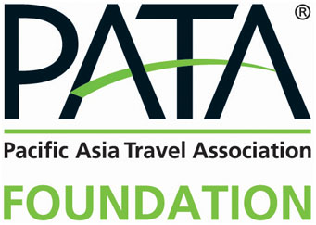

The Executive Development Programme in Hospitality
2017 Hong Kong PolyU Winter School
Hong Kong Polytechnic University
December 4-16, 2017
_____________________________________________________________________________________________________

(Please type or print clearly)
Please provide your PATA Membership number:

Section I: Personal Information
Dr / Mr / Mrs / Ms |  |  |  | First Name |  |  | Surname
Title / Position:
Organisation:
Address (Work):
Phone: |  |  |  |  |  | Fax:
Email:

In case of emergency contact:
Name |  | Relationship: |  | Phone:

Section II: Current Industry Experience

Person to whom you report:
Full Name:
Title / Position:
Phone: |  |  | Email:

What are the primary responsibilities of your position?

What type of organisation are you currently employed with? (select one)
Educational Institute | Government | Hotel
Media | Publication | Transportation
Travel Service | Tourism Association | Others

Section III: Previous Industry Experience & Education

What special professional interest in tourism do you have?

Principal position held previously
Organisation:
Dates: |  | Position:

SECTION IV:

Please select two of the following modules you wish to apply for sponsorship:
Mark “1” for your first choice. Mark “2” for your second option.

Luxury Hospitality Brand Management on December 4-5
Digital Marketing and Analytics on December 6-7
Revenue Management for Non-Revenue Managers on December 8-9
Strategic Talent Management: Recruiting, Selecting, Motivating and Retaining Employees for Long Term Success on December 11-12
Effective Training in Hospitality on December 13-14
Managing Organisational Change and Transformation on December 15-16

Section V: Deadline

The application must be submitted by October 20, 2017 to:

Miss Kay Kornchalee Tantimongkonsakul
Tel: (66-2) 658-2000
Email: foundation@PATA.org

