ELECTRICAL FACILITIES RENTAL
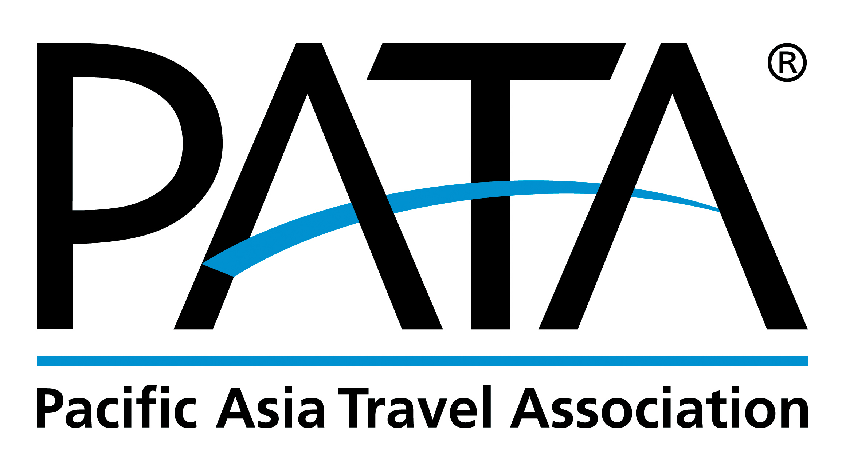

PATA Travel Mart 2019
September 18-20, Nur-Sultan, Kazakhstan
DEADLINE: August 25, 2019
Return Form to:

ITE Group Plc.
8th-floor Zharokov str. 42 05005 Almaty Kazakhstan

Contact: +7 727 2583449
Fax: +7 727 2583434
Email: denis.pivovarov@iteca.kz

Manpower Service / Interpreter
FORM
12

This form must be completed and returned by every exhibitor (if needed).
Company Name: _____________________________________________________ Country: _____________________________
Booth No.: ___ __ Contact Person: _________________________________ Email: ______________________
Tel: _____________________________ Website: __________________________________ Date: ____ ________

Role | KZT / USD (Daily) | Date |  | No. of Staff Required |  | Amount
 |  | From | To
Exhibition Helper | 41800 / 110 | 09:00 | 18:00
Interpreter Hostess (Basic translation) | 57000 / 150 | 09:00 | 18:00
Professional Interpreter | 83600 / 220 | 09:00 | 18:00
 |  |  |  |  | Total Cost
 |  |  |  |  | Grand Total

PLEASE NOTE:
- All personnel stated above are English speaking. Other language personnel will be quoted upon request. It is the responsibility of the contracting client to provide for the entry badges to the personnel on stand.
- Daily Rates for temporary exhibition helper services are charged on a maximum of 9 working hours per helper (includes 1hr meal break). Any extra hours will be charged 19000 / 50 KZT/USD. For work before 9 am, there will be 5000 / 13 KZT/USD for early transportation.
- Daily Rates for temporary interpreting services are charged on a maximum of 9 working hours per helper (includes 1hr meal break). Any extra hours will be charged 38000 / 100 KZT/USD. For work before 9 am, there will be 5000 / 13 KZT/USD for early transportation. Interpreter Hostess can provide basic translation service.
- Daily Rates for temporary professional interpreting services are charged on a minimum of 9 booking hours per day (includes 1hr meal break). Rate varies depends on profiles of the interpreter and field of translation.
- Temporary staff should be entrusted with the handling of cash or other valuables. Seller will be responsible for the safety or your own valuable stuff, the organizer will not be responsible for any losses or damages causes by such personnel.
- To confirm the services, please ensure to make the full amount payment (USD or KZT). Payment should be in favour of: ITE Group Plc. Below with the bank details for Transfer, please email or fax us a copy of wire transferred for the confirmation.
CURRENCY | KZT | USD
ACCOUNT NAME | ITECA LLP | ITECA LLP
BANK | JSC Citibank Kazakhstan | Citibank New York
ACCOUNT NUMBER | KZ1883201T0250001029 | KZ7983201D0250001006
SWIFT CODE | CITIKZKA | CITIKZKA

- If the payment is drawn in foreign current, please ensure to include the bank commission/fee. In any case that the final amount received is lesser than the said invoice (due to exchange rate variance), you will be responsible for reimbursing the relevant beneficiary.
- Any late Orders & Payment (received after the deadline, August 25) might not be provided; and if available, will be subject to 30% surcharge and 50% surcharge for any order place On-Site (received after August 25). Priority will be given to advance orders.
- 30% cancellation fees will be imposed on the cancellation of confirmed orders. Any cancellation on the set-up days/show days, the exhibitor will be liable for full rental cost and there will be no refunds.
- All Prices are in KZT and USD is also accepted, the exchange rate is USD1:KZT380. Please contact the official stand builder for further information.
- The services are subject to availability and on first come first served basis.
- ITE Group Plc. is entitled to add, alter, or amend these terms and conditions at its sole and absolute discretion without prior notice.

