ELECTRICAL FACILITIES RENTAL
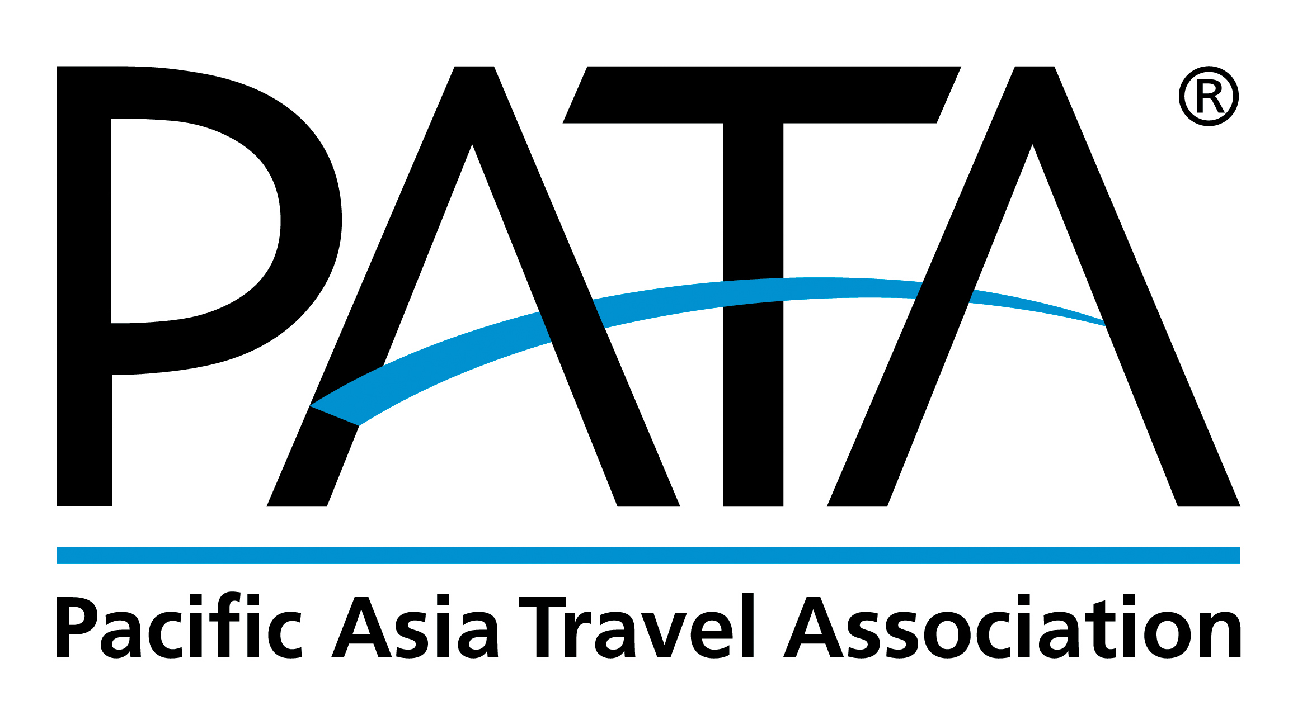

PATA Travel Mart 2019
September 18-20, Nur-Sultan, Kazakhstan
DEADLINE: August 25, 2019
Return Form to:

ITE Group Plc.
8th-floor Zharokov str. 42 05005 Almaty Kazakhstan

Contact: +7 727 2583449
Fax: +7 727 2583434
Email: denis.pivovarov@iteca.kz

FORM
11
Food & Beverages

This form must be completed and returned by every exhibitor (if needed).

Company Name: _______________________________________________ Country: _________________________
Booth No.: _________ Contact Person:______________________________ Email: ____________________________
Tel: ______________________ Website: _________________________________ Date: _______________________

If you wish to have catering service, please send this Form, for quotation by the Official Shell Scheme contractor ITE Group Plc. and tick the box below:

Please send us a quotation based on our requirements

Please insert short inscription in this box

PLEASE NOTE:
- To confirm the food & beverages, please ensure to make the full amount payment (USD or KZT) prior to the event. Payment should be in favor of: ITE Group Plc. The payment can be made in both currencies, KZT or USD, below the bank details:
CURRENCY | KZT | USD
ACCOUNT NAME | ITECA LLP | ITECA LLP
BANK | JSC Citibank Kazakhstan | Citibank New York
ACCOUNT NUMBER | KZ1883201T0250001029 | KZ7983201D0250001006
SWIFT CODE | CITIKZKA | CITIKZKA

- Please ensure to place your order within the deadline August 25 or before September 03, 2019. Any later order or order on-site will have a different price or might not be accepted.
- Exhibitor must indicate their Stall Number, dates of catering and amount to ITE Group Plc. while placing an order, for proper preparation.

