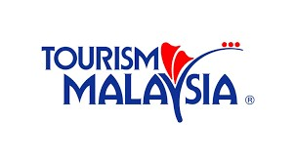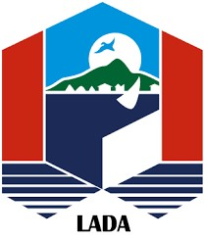

PATA Travel Mart 2018 Half Day Excursion Booking Form
(Self-Paying)
Dayang Bunting Island Jet Ski Tour
Visit 8 island in 4 hours riding on a jet ski
Excursion Date : 15th September 2018
For REGISTERED PATA Travel Mart 2018 SELLER, BUYER, MEDIA and SPOUSE only.

Please complete this form and send it to respective tour company listed below within July 30, 2018 .
Please tick appropriate boxes ☐ Seller ☐ Buyer ☐ Media
☐ Mr. ☐ Ms. ☐ Mrs.
First Name: |  | Surname:
Company: |  | E-Mail:
Address: |  | Mobile Phone: (in case of emergency only):
 |  | Country:
Time : | ☒ 09:00hrs | ☐ 14:00hrs
Hotel in Langkawi :
Accompanying Person ☐ Yes ☐ No (If Yes: Name: )

- Contact person Mr Hussein +60123890801 or sales@megawatersports.com

A brief description of our tour
We will bring you to some of the most exotic parts of Langkawi. First stop is the Dayang Bunting Island. About 10 minutes of jungle trekking you will then arrive at this big fresh water lake (surrounded by the ocean). You can swim, chill, or just enjoy the ambiance.
Off again on a jet ski, you will approach the Fjord. We will be going for a short dip in the ocean. This will be one of the few places in the world where you can swim in the middle of the ocean yet still be surrounded 360 degrees by jungle.
The next few islands shall be explored whilst on the jet ski. Visiting magnificent limestone structures dating more than 200 million years old (way older than Everest). The last two islands is where we will watch eagles flying in the wild. Our guides will explain about their habitat and you be able to visit the nearby mangroves that protect the island.
The final island will bring you to a small secluded island where you will be able to do snorkeling, or just chill on the beach and enjoy Langkawi's nature.
- The above tour programmes are subject to change. Please reconfirm the programme direct with the agent before making payment

