PATA Travel Mart 2018 ​
Post Tour Registration Form.​ ​
Please complete this form and send it to respective tour company listed below within July 30, 2018.

First Name ​: | Surname​ :
Company ​: | E-Mail​ :
Address ​: | Mobile Phone​ :
 | Country​ :
Departure date ​: | Flight no. and departure time from Airport​ : ​
Hotel ​:
Number of Pax​ :
TOTAL​ (MYR) :

NAME | GENDER | NATIONALITY | D.O.B | PASSPORT NO.

RATES

18 holes | 9 holes
RM 305 | RM 155

*Above rates are in Malaysian Ringgit & net price.

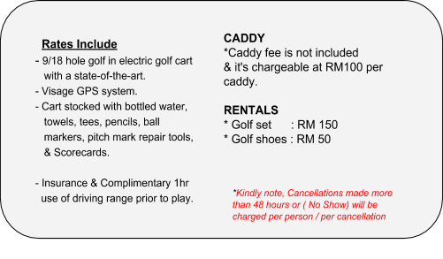

CONTACT US

THE ELS CLUB TELUK DATAI
reservations@elsclubmalaysia.com
+ 60 (04) 9592700 or reach our sales team
Hosni Sofian | ​ Sales Manager​
+60(12)3088834
Hosni.sofian@elsclubmalaysia.com
Muzani Zamri | ​ Sales Executive​
+60(12)2351538
Muzani.zamri@elsclubmalaysia.com

