SWIM WITH THE “WHALE SHARKS” AND DAY TOUR MISIBIS BAY RESORT

Tour Booking Form
For PATA New Tourism Frontiers Forum 2015 Delegate

******
PLEASE TYPE / WRITE IN BLOCK LETTERS (Best by printing from computer)
Mr Mrs Ms | First Name ______________________ | Surname ___________________
Company__________________________________________________________________________
Address ___________________________________________________________________________
Country ______________________________ Hotel stay in Legazpi ___________________________
Email ________________________________ Tel (in case of emergency) _______________________
Arrival flight / date (to Legazpi) _________________________________________________________ Departure flight /date (from Legazpi)_____________________________________________________

The same tour programme is offered for Pre/Post event:

Please tick one

Option A: Pre tour on November 24 | Option B: Pre tour on November 25 | Option C: Post tour on November 28

Time: 0700-1800 hrs.
Tour Duration 11 hours
Price: USD 120 (PHP 5,000 ) per person (USD 1 = PHP 42 as of July 2015)
Tour will run with a minimum of 4 people
Pick-up time 0700 at the hotel lobby
Expected arrival time at the hotel will be at 1800

* Inclusions - Transfers, boat services, guide services, snorkeling equipment, registration fees, lunch, snacks, and refreshments

For your booking and payment, please contact:
Ruby Lita -Whale Shark Adventures and Tours
Phone: +63 (0) 921 929 3811, +63 (0) 917 900 2464
Email: reservations_donsol@yahoo.com

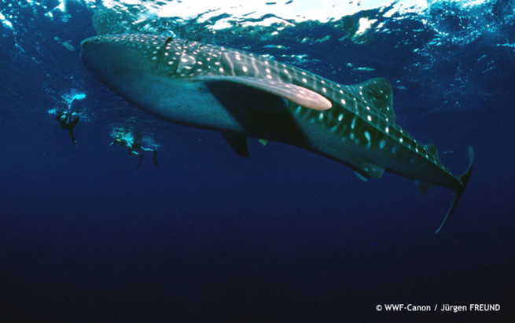
Donsol is one of the few places in the world that can offer an almost assured whale shark sighting from November to June. Here you can find adult and juvenile sized whale sharks in their natural and uninterrupted habitat. The name Donsol has become synonymous to whale sharks as the world’s largest congregation of whale sharks are found here and the whale sharks stay in Donsol longer than any other place in the world. With simple snorkeling equipment, you will have the opportunity to swim alongside these gentle giants.

RECOMMENDED THINGS TO BRING/WEAR

- Sun block
- Swimming Clothes
- Extra Clothing

