MISIBIS BAY TOUR
Tour Booking Form
For PATA New Tourism Frontiers Forum 2015 Delegate

******
PLEASE TYPE / WRITE IN BLOCK LETTERS (Best by printing from computer)
Mr Mrs Ms | First Name ______________________ | Surname ___________________
Company__________________________________________________________________________
Address __________________________________________________________________________
Country ______________________________ Hotel stay in Legazpi ___________________________
Email ________________________________ Tel (in case of emergency) _______________________
Arrival flight / date (to Legazpi) ________________________________________________________
Departure flight /date (from Legazpi) ____________________________________________________

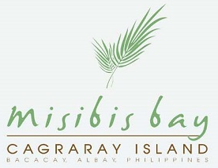 | Misibis Bay, your luxury island playground in the Philippines, is a private tropical hideaway built on a private, pristine stretch of beach along the southern tip of Cagraray Island in Bacacay, Albay (Bicol Region).  Offering only the most exclusive and privileged hideaway, Misibis Bay’s architecture and interiors display a quintessence of style that allows guests to completely wallow in royal delight. Its 37 luxurious, Asian-inspired villas are designed with high, airy ceilings, expansive terraces with direct access to the pool or a secret path to the beach. The exclusive 1-kilometer stretch of golden-sand beach is made even more unique with exotic shells and volcanic pebbles.

Please select:
Weekdays |  |  | Weekends
price | quantity | total price | price | quantity | total price
USD 35  per Adult |  |  | USD 40  per Adult
USD 20  per kid |  |  | USD 25  per kid

Grand total USD ________________

(USD 1 = PHP 42 as of July 2015)

For inquiries and reservation:
Call: + 639175991606 / +639214873869 / +639155006833
Email: reservations@misibisbay.com
www.misibisbay.com

