

PATA Travel Mart 2015
Bangalore International Exhibition Centre (BIEC)
Bangalore, India
September 6-8, 2015

This is to acknowledge that you have already downloaded the Seller Manual for PATA Travel Mart 2015

Company Name : ____________________________________________

Contact Person : ____________________________________________

Address : ____________________________________________
____________________________________________

Telephone : ____________________________________________

Fax : ____________________________________________

Email : ____________________________________________

Booth No. : ____________________________________________

Signature : ____________________________________________

Date : ____________________________________________

Company Stamp : ____________________________________________

Please fill in this page, complete it and email to:

Attn: Nararat Pak Vachiramanaporn
Assistant Manager - Events
Email: Nararat@PATA.org

Content

PTM2015 Floor Plan
Page
Time Table of In-Hall Operations 1
Order Forms Deadline Checklist 2
Important Matters 3

- General Information
1.1 Venue 4
1.2 Organizer 4
1.3 Media Workroom 5
1.4 Sponsoring, Supporting and Associate Organizations 5
  - Security - General / Individual 5
  - Public Address (PA) System 5
  - Internet / Wi-Fi Services 5
  - Medical Assistance 5
  - Parking 5
  - Taxi Service 6
  - Loading Capacity 6

- Official Contractor
2.1 Official Contractor / Agencies 7
2.2 Official Freight Forwarder 7

- Rules and Regulations
3.1 Presentations and / or demonstrations of exhibits / products 8
3.2 General Booth Cleaning 8
3.3 Removal of Waste 8
3.4 Operation of Booth / Conduct and Behaviour 8
3.5 Liabilities 9
3.6 Dilapidation 9
3.7 Force Majeure 9
3.8 Authority of Premises 9
3.9 Payment for Exhibition Space 9
3.10 Sound Level / Film and Audio / Visual Demonstrations 9
3.11 Industrial Gas and Naked Flame Demonstration 9
3.12 Fire Precaution 9
3.13 Photography of Exhibits 10
3.14 Removal of Exhibits 10
3.15 Refund of security deposit 10
3.16 Approval of layout plans of Stands 10
3.17 Service badges 10

- Accommodation, Transport and Registration
4.1 Visa and Entry Facilities 11
4.2 More Information about Bangalore, India 11
4.3 Hotel Accommodation 11
  - Transportation 12

5. Freight and Shipping Instructions
5.1 Consignment of Exhibits / Materials to Bangalore, India 13
5.2 Freight Handling / Delivery and Removal of Exhibits 13
5.3 Storage of Materials 14
5.4 Shipping by Courier Companies 14

6. Hall Specifications/Booth Fitting Regulations and Specification
  - Shell Scheme Specification 15
  - Electrical Supplies and Installation 15
6.3 Booth Fitting Regulations 16

- Shell Scheme Package 16
- Raw Space Booth / Shell Scheme Under Decoration 17
6.4 Seller Nominated Booth Contractor 19

Floor Plan

(To be released)
Time Table of In-Hall Operations

Event | Day / Date / Time
Build - Up Period  1. Official Contractor moves in to mark floor space from | Sat, 05 September, 0900 - 1800 hrs.
2. Outside Contractors move-in from | Sat, 05 September, 1600 hrs.
3. Delivery of Freight to Raw booth from  Note: Delivery of freight for Shell Scheme booth from | Sun, 06 September, 1400 hrs. onwards
4. Shell Scheme booth ready for occupancy on | Sun, 06 September, 1200 hrs. onwards
5. Registration of Sellers from | Sat, 05 September, 1400-1730 hrs.
6. Electrical Supply to booth from | Sun, 06 September, 1400 hrs. onwards
7. Completion of all booth construction by | Sun, 06 September, 1800 hrs.
8. Hall cleaning from | Sun, 06 September, 2000 hrs.
9. Completion of booth dressing and product display by | Sun, 06 September, 1800 hrs.
Exhibition Period  10. Seller-meet-Buyer Open Hall Session  11. Business Session (For Delegates)  Business Session #1  Business Session #2  Business Session #3  Business Session #4  12. Open to Trade Visitor Registration | Mon, 7 September, 0900-0945 hrs.  Tue, 8 September, 0930-1015 hrs.  Mon, 7 September, 1030-1220 hrs.  Mon, 7 September, 1400-1710 hrs.  Tue, 8 September, 1015-1245 hrs.  Tue, 8 September, 1415-1725 hrs.  Tue, 8 September, 0930-1700 hrs.
Break-Down Period  13. Packing of Exhibits, emptying rented furniture (drawers/cupboards) | Tue, 8 September, 1800 hrs.
14. Disconnection of all utilities | Tue, 8 September, 1800 hrs.
15. Collection of rented items/distribution of packing materials by contractors | Tue, 8 September, 1815 hrs.
16. Dismantling of Shell Scheme Booth | Tue, 8 September, 1830 hrs.
17. All exhibits must be packed and removed from the Hall by | Tue, 8 September, 2100 hrs.
18. Cleaning of Hall | Tue, 8 September, 2100 hrs.
19. All booth materials must be dismantled and removed from the Hall by | Tue, 8 September, 2100 hrs.
20. All sellers and contractors must leave the Hall by | Tue, 8 September, 2100 hrs.
21. Hand-over of Hall to Owner ( INCREDIBLE DESIGN - BIEC) | Tue, 8 September, 2100 hrs.

- The Exhibition Hall is open from 0900-1800 hrs. During build-up on Saturday 5 September and from 1800-2100 hrs. On Tuesday 8 September for break-down.

- On Exhibition days Sellers are permitted to enter the Exhibition Hall after 0830 hrs. and remain for half an hour after closing (1800 hrs.) to service their booths. For security reasons, sellers requiring to start earlier/stay later must obtain prior permission from the Organizer.

- Exhibits may be delivered to the booth earlier than the date specified if construction (in the case of “Raw space” booth) has progressed sufficiently to receive the exhibits. Please liaise with the Official Freight Forwarder for such arrangements. Sellers must be presented to receive such exhibits.

- Sellers are reminded that small, portable and attractive items especially Laptop are most at risk after the Exhibition closes each day or even during lunch time. Therefore, sellers are advised to keep these safety stored each day before leaving the Exhibition Hall. Sellers should pay particular attention to these items during the break-down period. PATA assumes no responsibility for any personal belongings in the event of loss or damage.

- Please note that ALL EXHIBITS MUST BE REMOVED BY THE RESPECTIVE TIMINGS STATED ABOVE.

PATA Travel Mart 2015
Order Forms Deadline Checklist

All sellers must complete this checklist and return to the respective
Addresses by the deadline indicated

Company Name : _______________________________________________ Country : _____________________

Contact Person : ___________________________________ Job Title : _______________________________

Tel : ______________________________ Email : _____________________________________

Booth No. : ____________ Date: ______/______/ 2015 Signature: _____________________________

Form No. | Description of Services | Deadline | Return To | Email | Tick  if Required
1 | Media Information | As soon As Possible | PATA | Communications@PATA.org
- | Hotel Booking Form | Tue, 04 August 2015 | Hotel’s Contact Person | - | -
2 | Fascia Name -  Shell Scheme Package | Tue, 04 August 2015 | Incredible Design | PTMINDIA2015@gmail.com
3 | Electrical Service | Tue, 04 August 2015 | Incredible Design | PTMINDIA2015@gmail.com
4 | Furniture Orders | Tue, 04 August 2015 | Incredible Design | PTMINDIA2015@gmail.com
5 | Service Location Plan | Tue, 04 August 2015 | Incredible Design | PTMINDIA2015@gmail.com
6 | AV Equipment Rental | Tue, 04 August 2015 | Incredible Design | PTMINDIA2015@gmail.com
7 | Manpower Services and  Interpreter | Tue, 04 August 2015 | Incredible Design | PTMINDIA2015@gmail.com
8 | Freight Instruction | Tue, 04 August 2015 | APT Showfreight (Thailand) | apiwat@aptshowfreight.com
9 A | Outside Contractor - Shell Scheme  (A) | Tue, 04 August 2015 | Incredible Design | PTMINDIA2015@gmail.com
9 B | Outside Contractor - Raw Space  (B) | Tue, 04 August 2015 | Incredible Design | PTMINDIA2015@gmail.com
10 | Plant and Floral Service | Tue, 04 August 2015 | Incredible Design | PTMINDIA2015@gmail.com
11 | Internet or Wi-Fi Access | Fri, 24 July 2015 | Incredible Design | PTMINDIA2015@gmail.com | Complimentary from Karnataka
12 | Food and Beverages |  |  | To be confirmed
13 | Service Badges | Tue, 04 August 2015 | Incredible Design | PTMINDIA2015@gmail.com
14 | Booth cleaning service | Tue, 04 August 2015 | Incredible Design | PTMINDIA2015@gmail.com

1. Sellers are requested to return this checklist to the relevant addressees by the deadline indicated. Please remember to attach Forms for all required services.

2. Sellers who sign up after the stipulated deadlines are requested to submit this checklist IMMEDIATELY.

PATA Travel Mart 2015
Bangalore International Exhibition Centre (BIEC)
Bangalore, India
September 6-8, 2015

Welcome to PATA Travel Mart 2015. In order to assist you in preparing for this Exhibition, we have designed this Manual to expedite your arrangements. Please return the necessary forms by the due dates so that we can ensure that the services you required are arranged before the Exhibition.

Sellers Should Be Aware Of the Following Important Matters

- The Exhibition Hall is open from 0900-1800 hrs. During build-up on Saturday and Sunday, 5-6 September and from 1800-2100 hrs. On Tuesday, 8 September for break-down.

Thereafter, all persons must leave the Hall for security reasons.

- Sellers who have reserved “Raw Space” must have their layout, design plans and elevation scale drawings (2 copies) to reach the Official Contractor by Monday, 10 August 2015 for approval.

- A “Decision Maker” from each seller is recommended to be available at/before 1000 hours on Sunday, 6 September 2015 to facilitate any last minute requirements.

- Only general cleaning is provided in-hall. This includes cleaning of carpet and emptying of wastepaper baskets. Please note that cleaning of exhibits is the responsibility of the seller. The removal/disposal of all construction debris and waste materials during the Exhibition are also the responsibility of the seller and the appointed contractors.

- Persons below 18 years of age are NOT permitted on-site through the build-up, break-down and the Exhibition days. Please note that this includes the children of sellers, contractors, and visitors. The accepted dress code during Exhibition days is Business Attire.

- Trade Visitors registration is open from 0930-1700 hrs. On Tuesday, 8 September 2015. Children and persons not connected to the travel industry will not be permitted entry into the Exhibition, even with such invitations.

- Packing/removal of exhibits followed by dismantling of booths can only commence after the Exhibition closes at 1730 hrs. on Tuesday, 8 September. All exhibits and booth materials must be removed from the hall between 1800 hrs. and 2100 hrs. on Tuesday, 8 September 2015.

- All sellers and their personnel must be aware of the Exhibition’s Time-Table of In-hall Operations, especially the build-up and break-down period, and must ensure that all activities are planned and carried out within these timing.

- Sellers must have adequate insurance cover against any and all eventuality throughout the whole duration of the Exhibition for their personnel, equipment, third party liability claims and movements of equipment in and out of the Exhibition premises.

If you have any queries, please contact:

PATA Travel Mart Team

Ms. “Mam” Puangthip Chotipantawanon, Director of Events Tel: 662 658 2000 # 120 email: Mam@PATA.org
Ms. Angkana Sakulpensuk (Buyer-specific), Manager - Events Tel: 662 658 2000 # 114 email: Angkana@PATA.org
Ms. Nararat Vachiramanaporn (Seller-specific), Asst. Manager - Events Tel: 662 658 2000 # 122 email: Nararat@PATA.org

All information contained in this manual is correct at the time of printing, as the Organizer has done their utmost to ensure their accuracy. The Organizer apologizes for any misprint, omission or error, and express regret. However, we cannot be held liable on any account whatsoever for them.

1. General Information

  - Venue

Bangalore International Exhibition Centre (Hall 1)
Address: 10th Mile, Tumkur Road, Madavara Post, Dasanapura Hobli, Bangalore 562 123, India
Tel: +91.80.66246600

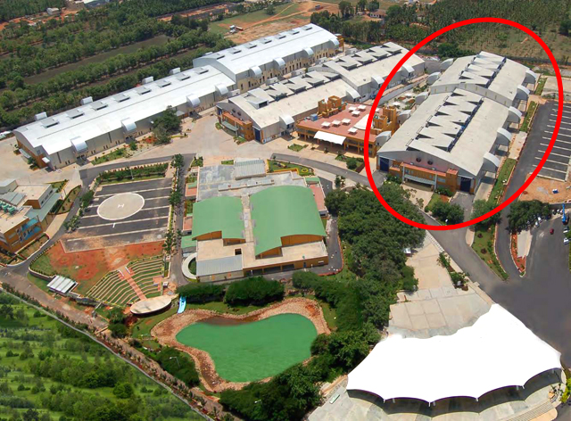

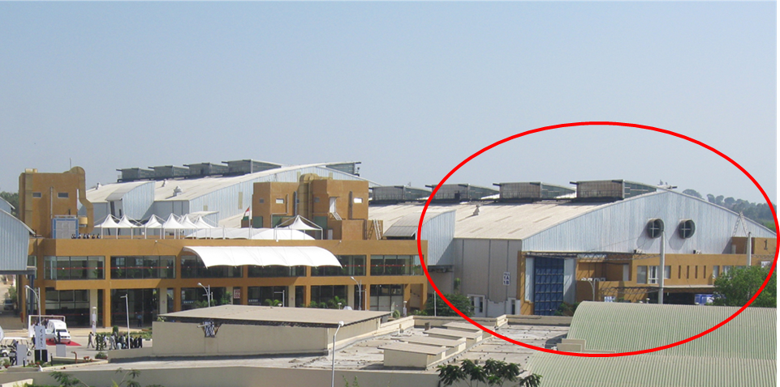

BIEC offers its exhibitors services and amenities of the highest quality on par with international standards. Beautifully landscaped over 34 acres near Peenya industrial township of Bangalore, this multi-purpose facility is a common ground for industry exhibitions, conferences, product demonstrations and training programmes.

BIEC complements its 40,000 sq. of covered space in three aesthetically and functionally designed exhibition halls, with a 5000 sq.m of open display area, perfectly suitable for showcasing large and heavy machines. VIP Lounge and Business Centre are attached with every hall, in addition to exhibition management facilities. The Conference Centre, The Food Court and other support services for exhibitor and visitor comfort, all within the same complex, make BIEC an unique and most sought after exhibition centre, in India.

  - Organizer

The Organizer will maintain the PATA Working Office on-site throughout the build-up, break-down and Exhibition days. Staff member will always be on hand to answer questions, handle problems, and be of assistance to all sellers. Any problem, which may arise on-site affecting sellers or contractors, should be referred to the Organizer immediately, so that prompt action can be taken.

  - Media Workroom

The Media Workroom location will be advised on-site. These rooms will operate from 0900-1700 on Sunday, 06 September 2015.

  - Sponsoring, Supporting and Associate Organizations

The Host Committee
- The Department of Tourism, Government of Karnataka

Official Airlines
- (To be confirmed)

Supporting Airlines
- Thai Airways International

Official Daily
• TTG Asia

  - Security - General / Individual

The Organizer has engaged alert and efficient security personnel to ensure the safety of all exhibits. Nevertheless, sellers must arrange their own insurance to cover all stages of Exhibition, and be particularly careful to pack all items / exhibits immediately after the Exhibition close on Tuesday, 8 September 2015. It is at this time that there is the greatest risk of exhibits and valuables going astray.

The Organizer will not accept responsibility for theft, loss or damage of exhibits, stores or any other equipment belonging to sellers, contractors or visitors.

It is strongly recommended that at least one representative is at your booth to supervise all deliveries, packing, unpacking, installing and dismantling until hand-over to your nominated agent.

Sellers are advised that rented furniture will be collected when the Exhibition closes, drawers, cupboards, store rooms, etc. should be emptied and contents packed away.

  - Public Address (PA) System

The PA system is for use by the Organizer and Hall Owner for Official Announcements Only. Paging services cannot be provided, nor can sellers’ announcements be made.

  - Internet / Wi-Fi Services

Complimentary Wi-Fi services are provided to all delegates sponsored by Department of Tourism of Karnataka.

  - Medical Assistance

First Aid room with medical assistance including doctor and ambulance, in case of emergency, will be available at BIEC during the fair period, including pre & post exhibition period.

  - Parking

Pre-exhibition period from 0000 hrs. - 05 Sept 2015
Freight vehicles carrying exhibition goods must enter from the main gate of BIEC. Exhibitors
are requested to follow the schedule of arrival & installation of exhibit. In case, Exhibitor fails
to follow the schedule provided by the Organiser, freight vehicles will not be allowed to park
inside BIEC complex. However, freight vehicles may be parked in the designated parking area
outside BIEC complex before off-loading of exhibition goods. Movement of freight vehicles
will be managed by the official security agency in co-ordination with the official site handling
agencies. Only Goods carrier vehicles would be allowed to enter inside the exhibition premises.
Personal vehicles such as cars, Jeeps, Vans, SUV etc. carrying goods will not be allowed
during setup and dismantling period.

During exhibition from 06 - 08 Sept 2015

During exhibition days from 06 - 08 Sept 2015, vehicles (personal and/or freight vehicles) will
not be allowed inside BIEC Complex. They are to be parked in designated parking areas only.

Post-exhibition period 08 Sept 2015

Freight vehicles for removing exhibition goods must enter from the main gate of BIEC, as per
schedules provided by the Organiser & official site handling agencies and will not be allowed
to park inside BIEC complex before and after reloading of exhibition goods. However, freight
vehicles may be parked in the designated parking area outside BIEC complex only before
reloading of exhibition goods. Movement of freight vehicles will be managed by the official
security agency in co-ordination with the official site handling agencies. Heavy freight vehicles
for removing exhibits above 1 Ton will not be allowed inside BIEC complex until 2100 hrs. on
08 Sept 2015.

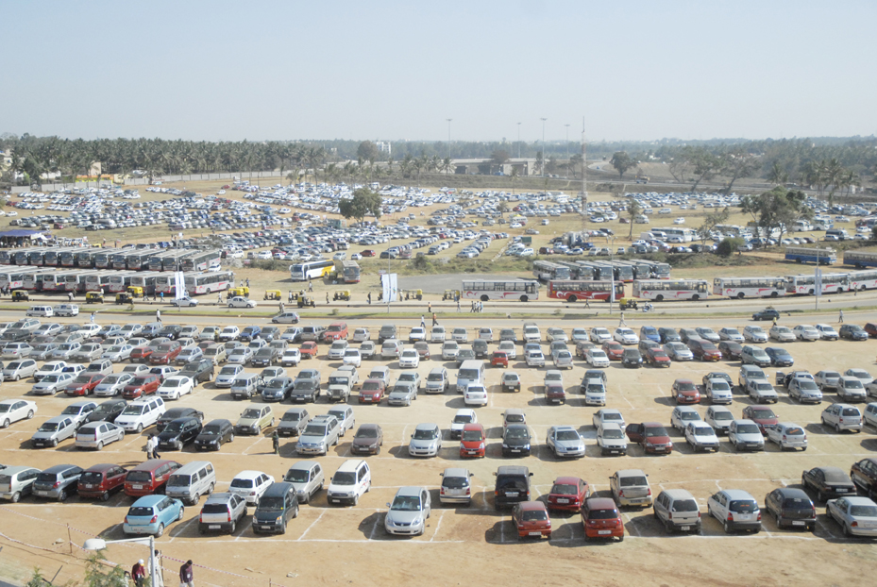

  - Taxi Service

Please contact Hospitality desk.

  - Loading Capacity

The venue capacity of Hall 1 is 6638.4 sq/mtrs and has the Floor loading capacity of 30 MT/sq.m.

Heavy freight vehicles for removing exhibits above 1 Ton will not be allowed inside BIEC complex until 2100 hrs. On 08 Sept 2015.

2. Official Contractor / Official Freight Forwarder

  - Official Contractors / Agencies
The following companies have been appointed as Official Contractors/Agencies for the Exhibition:

- Shell Scheme, Furniture Rental, Electrical, A/V Equipment Rental and Manpower Service

Incredible des!gn
B 143, First Floor, Mayapuri Industrial Area, Phase 1,
New Delhi 110064

Contact: Ar. Sanjay Soni
Email: ptmindia2015@gmail.com
Website: http://www.incredibledesign.in/
Contact: +91(0)9810149530
Fax: +91-22-66459233

Incredible des!gn responsibility covers all shell scheme construction, rental of furniture, electrical fitting installation, A/V Equipment rental and Manpower service in hall.

For your easy reference, the bank detail of the Official Contractor is listed below:

INR | EURO | USD
Account Name: INCREDIBLE DESIGN  Account No : 05512020000809  IFSC Code(For RTGS):HDFC0000551  MICR Code: 110240086  SWIFT CODE: HDFCINBB  Bank add: HDFC Bank Ltd. Shop No.1,  Community Centre, Phase-I,  Mayapuri, New Delhi-110064 | Account Name: INCREDIBLE DESIGN  Account No : 05512440000030  IFSC Code(For RTGS):HDFC0000551  MICR Code: 110240086  SWIFT CODE: HDFCINBB  Bank add: HDFC Bank Ltd. Shop No.1,  Community Centre, Phase-I,  Mayapuri, New Delhi-110064 | Account Name: INCREDIBLE DESIGN  Account No : 05512430000061  IFSC Code(For RTGS):HDFC0000551  MICR Code: 110240086  SWIFT CODE: HDFCINBB  Bank add: HDFC Bank Ltd. Shop No.1,  Community Centre, Phase-I,  Mayapuri, New Delhi-110064

  - Official Freight Forwarder

- Freight Forwarding, Lifting and Handling
APT Showfreight (Thailand) Limited
11/24 Ratchadapisek Road, Chongnonsee,
Yannawa, Bangkok 10120, Thailand
Tel: + (66-2) 285-3060
Fax: + (66-2) 285-3068
Website: www.aptshowfrieght.com
Email: trakul@aptshowfreight.com
Ctc: Mr Trakul Songtrakul

APT Showfreight (Thailand) Limited will provide and handle (for a fee) all the movements of freight and exhibits into and out of the Exhibition Hall that require any form or mean of mechanical lifting and handling equipment. They also provide customs documentation and censorship clearance as well as the hiring of labour on-site.

3. Rules and Regulations

The rules and regulations listed below are designed for safety, security, and to provide equal exposure for all sellers.

Sellers and their personnel/appointed agents must observe the rules and regulations stated in this Seller Manual and those attached to the Exhibition Participation Agreement.

3.1 Presentations and / or demonstrations of exhibits / products

A seller intending to present and/or demonstrate equipment, exhibit or product at his booth must:

- Give proper consideration to the safety conditions under which the exhibit will be demonstrated.

- Ensure that toxic fumes, exhaust or other irritants caused by the exhibits/products are not released into Exhibition hall. Prior approval from the relevant controlling authority, in addition to that of the Organizer, must be obtained for such purpose.

- Ensure that gas cylinders, naked flames and welding demonstrations are not exposed in the Exhibition Hall and booths. Prior Fire Safety Bureau (FSB) approval must be obtained and their conditions for such purpose fully met and satisfied before any demonstration is carried out.

- Ensure that adequate protection is catered to prevent damage to the hall flooring, carpet and facilities. Any damages caused will be at the responsibilities of the seller concerned.

- Ensure that any product or display like roofing, awning, ceiling or lighting pelmet must be highlighted in the respective stand plan and submitted to the Organizer for the Fire Safety Bureau (FSB) approval. Without this FSB approval, no such product or display will be permitted in this Exhibition by the FSB.

- Ensure that all the relevant local government authority license(s) and / or permit(s) are obtained and its stipulated regulations and conditions observed and abided with for the demonstration and/or use of electronics, radio and / or satellite transmitting equipment.

- Ensure that only products for which they are agent, distributor or dealer, are displayed. In the event of a dispute between / among sellers, the Organizer reserves the right to rule on the right to exhibit.

3.2 General Booth Cleaning

The Organizer will arrange for the general cleaning of the Exhibition Hall and booths. This only includes cleaning of carpet / flooring and rubbish disposal before the Exhibition opens in the morning and after the Exhibition closes in the evening. It excludes cleaning of exhibits and displays. Sellers are responsible for maintaining their own booth in a tidy condition at all times. Sellers with lockable offices are requested to place refuse outside the office before departure each evening, for disposal. Sellers may contact Official Contractor for quotation, should addition cleaning services be required.

3.3 Removal of Waste

During the build-up and breakdown days of the Exhibition, the aisle of the Hall must not be obstructed with packing and construction materials or debris. Contractor building space only booths or booth interiors are responsible for removing their own building waste and off-cuts from the site at the end of each day. Painting and sawing can only be carried out at a certain designated areas outside the Exhibition Hall.

At the end of Exhibition, contractors must remove from the site all the materials especially the double-sided carpet tape used from their clients’ booths by the respective timings stated in the Time Table of in Hall Operations. Should they fail to do so; the monies of their performance bond will be used to pay for such removal by the Official Cleaning Contractor.

The Organizer reserves the right to charge the seller concerned for the removal of excessive waste (booth construction debris, crates/pallets, cartons, packing materials or literature).

  - Operation of Booth / Conduct and Behaviour

All exhibition booths must be fully staffed and operational throughout the opening hours of the Exhibition. Sellers must not participate in any activities that may causes, or is likely to cause, annoyance to visitors or other sellers.

All activities of the seller and his staff must be confined to the booth or site allocated. No advertising or canvassing for business may take place elsewhere in the Exhibition Hall. This includes the distribution of leaflets, brochures, journals, etc. Sellers may not use the Exhibition for recruiting staff, other than to seek local agents for their products.

  - Liabilities

It is agreed that neither the Organizer nor any of its officer, directors, members or employees shall have any liability or responsibility for any personal injury, property damage or loss suffered by a delegate or any of his/her family members or other persons attending the PATA Travel Mart with the delegate resulting from the action or inaction of any person other than an employee of PATA.

In the event of, or likelihood of, any circumstance which may create and extraordinary risk of injury or damage, PATA shall have the right in its sole discretion, to determine the course of action to be followed in respect to the 2015 PATA Travel Mart. In the event that PATA cancels or limits the Mart for reasons of safety, neither PATA nor any it’s officer, directors, members or employees shall have any liability or responsibility in connection with such cancellation or limitation and their failure to perform any further obligations shall not constitute a breach of contract on the part of PATA to hold such Mart.

  - Dilapidation

Sellers are responsible for the cost of making goods or replacing any damage or dilapidation to the Exhibition premises, whether caused by themselves, their agents, and contractors or by any person or persons employed or engaged on their behalf by such agents or contractors.

Sellers occupying shell scheme booths are also responsible for the cost of making goods, any damage to the contractor’s booth structures, floor coverings, light fittings and any other hired items, whether caused by themselves, their agents, contractors or by any person or persons employed or engaged on their behalf by their agents or contractors. The cost of damages and losses will be stated by the relevant contractor and charged to the seller concerned.

  - Force Majeure

The Exhibition may be postponed, shortened or extended due to any cause whatsoever outside the control of the Organizer. In such an event, the Organizer shall not be responsible for any loss sustained by the seller, directly or indirectly attributable to the elements of nature, force majeure or orders and directives imposed by any governmental authority, and fees paid by the seller, in full or any part thereof, are refundable at the sole discretion of the Organizer.

  - Authority of Premises

In the event of any problems or disputes on-site, the decision of the Organizer, being lessee of the premises, will be final. The Organizer also reserves the right to amend any earlier decision made in order to meet and satisfy any unforeseen or prevailing circumstance for the benefit of the Exhibition and concerned parties.

  - Payment for Exhibition Space

No seller may begin booth construction or move their exhibits into the Hall or surrounding area until full payment, including deposits, have been received by the Organizer.

3.10 Sound Level / Film and Audio / Visual Demonstrations

Sound levels should not exceed 80dB measured from the nearest point of adjoining stands, which cause no interference with or annoyance to other Sellers.

If the Seller continues to refuse to comply with the request to reduce the volume, the Organiser reserves the right to disconnect all power supplies to the stand and no compensation will be made to the Seller.

3.11 Industrial Gas and Naked Flame Demonstration

The use of industrial gases of an inflammable or toxic nature for demonstration purposes will not be permitted in the Exhibition Hall.

3.12 Fire Precaution

All materials used in stands and exhibition constructions must be properly fireproofed in accordance with local regulations. Fire marshals will patrol the Exhibition facilities and will be authorized to stop any demonstration that is of potential fire hazards.

 SMOKING IS PROHIBITED IN THE EXHIBITION HALL AT ALL TIMES 

3.13 Photography of Exhibits

Commercial photographers, representing the appropriate media or individual visitors to the Exhibition may wish to photograph Exhibition booths or an individual exhibit. General photography of the Exhibition and exhibits is permitted; however ‘head-on’ photography or ‘close-ups’ of any exhibits lies within the Seller’s jurisdiction. Please note that the Sellers have the right to request any such person not to carry out photography without specific permission.

Sellers wishing to restrict photographs for any reason should place notice to that effect, adjacent to the exhibit, and are advised to hire their own security guards to enforce this restriction.

3.14 Removal of Exhibits

Exhibitors are allowed to remove exhibits from their stands only on conclusion of PATA 2015 on 08 Sept 2015. The work on dismantling of the stand and removal of exhibits must be completed latest by 2100 hrs on 08 Sept 2015. After this date, the Organiser reserves the right to remove the goods from the exhibition site at the cost and risk of Exhibitors.

3.15 Refund of security deposit

Security deposit of exhibitors would be refunded approximately within 30 days from the last date of the Exhibition, provided all dues towards participation and other charges.

3.16 Approval of layout plans of stands

Exhibitors must submit the design and drawing of their stall (floor plan & elevation) in 3D view(three dimensional view) depicting position of exhibits, furniture, fittings, fixtures, brandings, office cubicles with complete dimensions in meters, in duplicate, to the Organiser for approval by Monday, 10 Aug 2015.
Exhibitors failing to submit their stall drawings for approval by 10 Aug 2015 will be charged a late submission fee of INR 10,000.

3.17 Service badges

Each Exhibitor, if required may collect Service Badges from the official contractor by filling up the FORM 13. Service Badges Form 13 is available in the website.
These badges will not be mailed. Badges will be distributed from the Registration counters at the entry plaza of the exhibition site/Hall 1 from 05 Sept 2015 onwards. Badges will be handed over only to the authorized representatives of Exhibitors. Exhibitor in possession of Exhibitor Badges will be entitled to enter Exhibition Venue during Setup, Exhibition period and Dismantling. Person in possession of Service Badge will be allowed to enter the Exhibition Venue during Setup and Dismantling only.

Exhibitors are responsible for the safe custody of the badges. For reasons of safety, possession of Exhibitor badges by unauthorized persons is strictly prohibited. Exhibitor badges are not transferable and must be worn in/on person at all times within the BIEC complex.

Five (5) Contractor Badges will be issued for every 9 sq. m. of construction, up to a maximum of thirty (30) badges per contractor.

4. Accommodation, Transportation and Registration

  - Visa and Entry Facilities

All foreign nationals entering India are required to possess a valid international travel document in the form of a national passport with a valid visa obtained from an Indian Mission or Post abroad.
All Individual visa seekers are requested to apply for the Indian Visa through Online application link, in order to make an application for getting the Indian visa.
The duly signed physical copy of the application form completed in all respect and submitted successfully, is to be submitted at the concerned Indian Visa Application Centre (IVAC) or directly to Indian Mission/ Post, on the scheduled date of interview along with the requisite supporting documents. The instructions for filling the form and scheduling the appointment can be seen at Instructions for Online Visa Application. Important technical information for filling online Indian visa application can be referred at Technical Instructions.

Visa on Arrival (VOA); Applicants of the eligible countries may apply online for the Electronic Travel Authorisation (ETA) minimum 4 days in advance of the date of arrival with a window of 30 days. The fee must be paid 4 days before the expected date of travel filled by you otherwise application will not be processed. The ETA is valid for entry through 9 designated Airports namely Bengaluru, Chennai, Cochin, Delhi, Goa, Hyderabad, Kolkata, Mumbai, and Trivandrum. Applicant should carry a copy of ETA along with him/her at the time of travel. The validity of visa will be 30 days from the date of arrival in India with a maximum of two visits in a calendar year. For more information, visit https://indianvisaonline.gov.in/visa/tvoa.html.

  - More Information about Bangalore, India

The information below was retrieved from http://www.karnatakatourism.org, please visit this website for more useful tips and information on India.

a) Official Languages: The language of business is English. Hindi is the national language, but there are 14 other official languages: Bengali, Telugu, Marathi, Tamil, Urdu, Gujarati, Malayalam, Kannada, Oriya, Punjabi, Assamese, Kashmiri, Sindhi and Sanskrit.
- Time: GMT+05:30

- Currency: The Indian rupee (₹) is divided into 100 paise (p), but paise coins are becoming increasingly rare. Coins come in denominations of ₹1, ₹2, ₹5 and ₹10 (the 1s and 2s look almost identical); notes come in ₹5, ₹10, ₹20, ₹50, ₹100, ₹500 and ₹1000 (this last is handy for paying large bills but can pose problems when getting change for small services).

- Electricity: Electricity in India is 230V, with a frequency of 50hz, the following plugs are used:
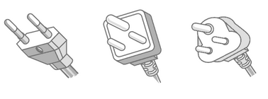

- Dress Code: Business attire is the official dress code during trading hours at the Exhibition Hall. The dress code for evening social functions, unless otherwise specified within the programme, is smart casual.

  - Hotel Accommodation

To be confirmed

  - Transportation

(a) Arrival Transfer: Airport transfers between Kempegowda International Airport (BLR) to PTM2015 official hotels will be made available to all registered delegates arriving on September 5-6, 2015

Departure Transfer: Airport transfer will be providing on September 8-10, 2015.

Please check transfer schedule at the Hospitality Desk onsite again.

If you arrive or depart prior to or after these dates, or if you are not staying at one of official hotel, you will be required to make your own transfer arrangements.

- Show Days / Official Functions Shuttle

Transfer to all business and official social events will be provided.

- Freight and Shipping Instructions

5.1 Consignment of Exhibits / Materials to Bangalore, India

To ensure that your exhibit materials imported into India are customs-cleared and delivered to your booth in time, please contact the official freight forwarder for consignee details and notify party. Please DO NOT send the shipment to hotel or via courier service as it is not recommended.

Shipment via courier may cause problems at customs or high amount of import duty & tax. And we do not have any control on couriers.

If you have any query, please consult our Official Freight Forwarder, APT SHOWFREIGHT (THAILAND) LIMITED

5.2 Freight Handling / Delivery and Removal of Exhibits

The Official Freight Forwarder or their agent(s) will make contact with each Seller regarding documentation procedures and deadlines for shipping exhibits.

As the Official Freight Forwarder, APT SHOWFREIGHT (THAILAND) LIMITED will provide all lifting and handling equipment in-hall as well as labour.

Please ensure that all exhibits and displays are sufficiently insured for all the stages of the Exhibition, and that all exhibits and displays are properly packed and crated with shock absorbing materials to prevent damage caused in transit and during delivery to booths and vice-versa on-site.

(a) Shipping Deadlines

The following is a schedule of deadline dates for action by Sellers' nominated forwarder(s) and information of / action by the Official Freight Forwarder.
Receipt of documents for sea freight consignments : 5 August 2015
Arrival of sea freight : 5 August 2015

Receipt of documents for air freight consignments : 15 August 2015
Arrival of air freight : 19 August 2015

(b) Lifting and Handling On-site

Only APT SHOWFREIGHT (THAILAND) LIMITED is permitted to work inside the Exhibition Hall and operate lifting equipment. Any forwarder may deliver to the door of the Hall, but APT SHOWFREIGHT (THAILAND) LIMITED must handle it from the freight entry up to Exhibition booth, unless the item(s) can be hand-carried by one (1) man. This regulation will be strictly enforced and is necessary for reasons of safety, insurance and control / co-ordination of in-hall movements.

(c) Local Deliveries and Hand-carried Items

Exhibits should not be sent to the Exhibition Hall until the booth construction has progressed sufficiently to receive them (see the Time-Table of In-Hall Operations). The Seller and / or his representative must be present at his own booth to accept delivery of freight. The Organizer will not accept any delivery on behalf of the Seller, nor can we be responsible for any failures in delivery. The Organizer will not be responsible for the safekeeping of items, which arrive in advance of the Seller's staff.

It is recommended that a representative of the Seller, who is authorised to make decisions, should be available on Sunday, 6 September 2015 to facilitate any last minute requirements. This representative should also be present earlier if required to hand over or receive goods from the Official Freight Forwarders to avoid any loss or damage.

Access to the Exhibition site is restricted. Sellers must ensure that the delivery, loading and unloading of goods is via the bay designated by the Official Freight Forwarders. Vehicles at these loading / unloading bays will be under the supervision and direction of APT SHOWFREIGHT (THAILAND) LIMITED and the Hall Owner / Exhibition Security Officers, who will see that the operation is carried out smoothly.

(d) Delivery of Exhibits during Build-up (5-6 September 2015)

Exhibits requiring mechanical assistance must be handed over to the Official Freight Forwarder at the loading / unloading bay. Sellers using their own freight forwarder to these areas are requested to submit their details to APT SHOWFREIGHT (THAILAND) LIMITED on Form 8 in order to facilitate co-ordination.

To avoid congestion in-hall, only small items and / or goods that can be taken out of their cases without risk of damage to the floor and Hall should be unpacked inside the Exhibition premises. For major items, Sellers should arrange with the Official Freight Forwarder to unpack away from the Exhibition premises and bring these items to the stand for positioning.

Exhibits should only be sent into the Exhibition Hall when the booth construction has progressed sufficiently to receive them. The Seller and / or his representative must be present at his own booth to accept delivery of freight/exhibits. The Organizer will not accept any delivery on behalf of the Seller, nor can we be responsible for failure in delivery, nor safekeeping of items, which arrive in advance of the Seller's staff.

(e) Delivery of Exhibits during Exhibition Days (6-8 September 2015)

Removal or delivery of exhibits and other Exhibition stores Will Not Be Permitted during Exhibition Opening Hours. Such removal, delivery or replenishment of stock may only be carried out before opening hours in the morning or after closing time in the evening.

(f) Removal of Exhibits

Should Sellers and their contractors / agents / suppliers wish to remove any items from the Hall, a “GOODS REMOVAL PASS” must be obtained from the Exhibitor Service Centre on-site. This applies to the Build-up, Tear-down, and Exhibition days. For removal of VCR, TV, projector, refrigerator, etc, the registration serial number(s) of the unit must be provided for the "GOODS REMOVAL PASS" application.

In order to reduce the possibility of theft, all valuable and portable items / exhibits must not be left unattended and be removed from the Hall on the evening of 8 September 2015. Sellers are strongly advised to ensure that at least one member of their staff is on-site to supervise and co-ordinate the re-packing and removal of their exhibits. Dismantling of some booth will commence on the evening of 8 September 2015. All items / exhibits must be removed by the respective timings stated in the “Time-Table of In-Hall Operations”.

Please ensure that all your exhibits and displays are properly packed and handed over to your agents / contractors before leaving the Exhibition Hall.

5.3 Storage of Materials

The Organizer is unable to provide in-hall storage facilities for packing cases, surplus materials or other property of the Seller. Arrangements for safekeeping of such items must be made with the Official Freight Forwarder.

5.4 Shipping by Courier Companies

Exhibitors are strongly advised not to courier goods for this exhibition as it could be detained by the customs. But if exhibitors still insist to send it via courier, please check with official forwarder for the address.

Please send copy of AWB / courier waybill and commercial invoice & packing list to us as soon as the shipment uplifted (via fax or email) so that we can monitor the shipment for you.

Please kindly be informed that there will be a delivery charge for courier shipment, rate will be quoted upon request. Please contact us if you need a quotation.

- Hall Specification / Booth Fitting Regulations
and Specifications

  - Shell Scheme Specifications

Shell scheme booths will be built from Octanorm modular system. The following items will be provided in the package (based on a 9 sq. m. booth), please click to view the Standard Shell Scheme Booth Layout (link to be uploaded).

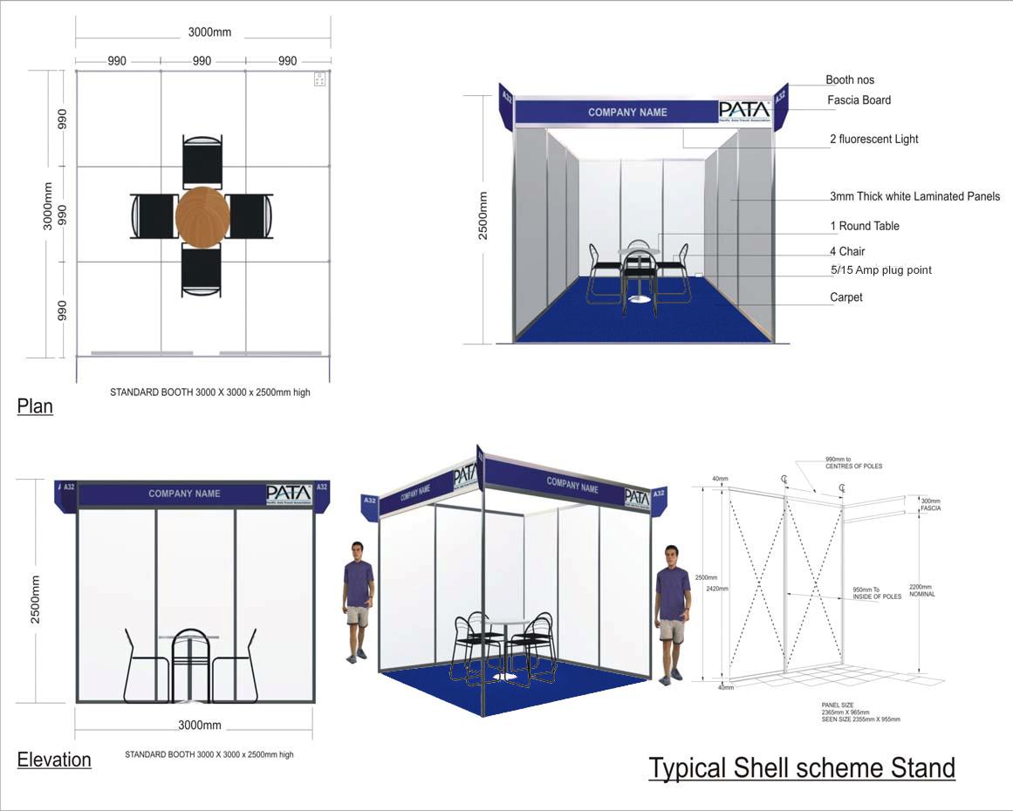

(a) Rear and Dividing Walls

2.47 metre high walls, with 950mm wide panels painted white, set in aluminium frames

(b) Fascia

The fascia is approximately 300mm deep, with in-fill panel of 230mm, and runs the length of the aisle faces, with white upper case letterings & blue colour background Pantone 294C, PATA logo and Booth numbers.

(c) Floor Covering

Dark grey colour needle punch carpet

(d) Electrical and Furniture Items

  - One (1) Round Table (size: Diameter 80 x 75 cm high)
  - Four (4) Chairs
  - Two (2) 40W Fluorescent Light / Three (3) spot Light
  - One (1) 220V / 500 W single Phase Power Socket (for exhibits, not for lighting)
  - One (1) Wastepaper Basket

  - Electrical Supplies and Installation

General Hall lighting is available in hall at a level of between 300 and 600 lux, depending on location.

The standard electrical current supply available for use on stands at the Exhibition are:-
- Single-Phase alternating current at 220 volts, 50Hz (+/- 0.5%)
- Three-Phase with neutral alternating current at 380 volts, 50 Hz (+/- 5%)

For safety reasons and for the protection of electrical installation at the Exhibition premises, all power main installations from source to outlet (Exhibition booths) must only be carried out by the Official Electrical Contractor. Any deviation from this regulation will only result in supplies not being switched on. As Organizer / Show Manager, we seek your kind cooperation in this matter as it is only beneficial to all parties concerned.

Connection of exhibits within the booth may be carried out by the Seller’s technician, but they must be inspected by the Official Electrical Contractor before circuits will be made live.

Each electrical supply provided is intended for one equipment or machine on display. Multipoint sockets outlets are not permitted as an overload may be caused, leading to a trip in the incoming power supply. Severe trips may take hours to rectify, thereby causing inconvenience to all Sellers.

No electrical installation or fittings may be suspended from the ceiling of the Exhibition Hall or fixed to any part of the building structure without any prior permission of the Organizer / Show Manager and the Hall Owner and, if permitted, a fee may be levied.

The Organizer / Show Manager reserves the right to disconnect electrical supply to any installation, which in the opinion of the Electrical / Safety Officer is dangerous or will cause annoyance to visitors or to other sellers.

Please place orders early to facilitate submission of electrical plans to the Authority for approval. Late or wrong orders will cause delays in the supply to your booth. Please note that the physical conditions of the Exhibition being different from those of the Seller’s premises, may affect the electrical supplies and installations and thus allowances must be factored onto the orders made.

Electrical arrangements for Exhibition booths can be ordered by using Form 3.

Sellers requiring 24-hour supply must submit in writing their requirement, at least two (2) weeks prior to the build-up date, to the Official Electrical Contractor, and any additional cost due to wiring, consumption, inspection fees, levies, etc. must be borne by the Seller concerned.

Requests for any items not listed in Form 3 can be directed to the Official Electrical Contractor (Incredible Design).

Supplies to booths will be from one (1) hour before to thirty (30) minutes after Exhibition hours each day. And supplies to booths during Build-up and Break-down period are stated in the Time table of In Hall Operations.

Please remember to indicate the locations of any additional electrical fittings you require on Form 3, so that the electrical and service engineers and staff can prepare your requirements before you arrive at the Exhibition site.

  - Booth Fitting Regulations

Sellers are advised to inform their nominated booth contractors of these regulations and to ensure their strict compliance:

- All parts of this Section are inter-related and are to be complied with collectively, where applicable.

- All dimensions and positions of stands and utilities services are estimate and must be verified and confirmed only onsite, and adjustments to the stand construction must be made to accommodate any such variation.

- Sellers and their contractors must take note and adhere to the timings for the build-up and breakdown periods stated in the Time table of In Hall operations when preparing and constructing their booths and exhibit display as extension of these timings may not be possible due to the fact that the Exhibition Hall might have already been booked for other events; and when an extension is possible, the charges involved are very costly and must be borne by the Seller or their contractor concerned.

- Shell Scheme Package

PATA has appointed Incredible Design as the Official Contractor for all Shell Scheme booths. However a Seller may employ a contractor of his choice to construct booth interiors and any free-standing displays or fitments that may be required, subject to all rules and regulations:

  - No additional fittings or displays, including additional name boards, covers, logos, balloons, etc are to be attached, nailed, screwed or drilled to the Shell Scheme booth structure. If this instruction is ignored, the Official contractor reserves the right to charge the Seller or Contractor concerned for any damages to the materials. The Official Contractor may provide assistance in hanging or displaying exhibits on the booth structure whenever possible. Please consult them if you require their assistance.

  - No painting, wallpapering or pasting of panels is allowed. Sellers who wish to have such works done on the panels must inform the Official Contractor, who will provide a quotation and carry out the work. Any double-sided or adhesive tapes belonging to the Seller or contractor must be removed from the panels after the Exhibition.

  - The fascia is approximately 2970mm broad, including the aluminum frame. Sellers may add their company logo not wider than 210mm (size of the in-fill panel), and not more than 10mm thick, by arrangement with the Official Shell Scheme Contractor.

  - Any changes in the type or colour of the floor covering provided, must be negotiated with the Official Contractor. All costs incurred must be borne by the Seller.

  - Seller occupying a corner booth has the choice of a wall or an additional open side to the aisle. And any such wall may be required to be set into the booth or by half metre as deemed necessary by the Organizer / Show Manager for safety reason or exposure of other Sellers.

  - No financial credit or item exchange will be given by the Organizer / Show Manager for any Shell Scheme package items not utilized.

- Raw Space Booth / Shell Scheme Under Decoration

These rules also apply to contractors doing addition works or interior decoration to Shell Scheme Booths.

Sellers, who have booked “Raw Space” booths may use either the Official Contractor or appoint another contractor of their choice, subject to the approval of the Organizer / Show Manager and Hall Owner. The Seller and his contractor will have to comply with the following rules and regulations.

- All works in the Exhibition Hall should be confined to installation and minor alternation works only. Fabrication works like welding, cutting, sawing, laminating, painting, spraying etc. should not be carried out inside the Exhibition Hall. Severe restrictions and penalties will be imposed on anyone who infringes this regulation. This is a safety and health measure.

- The Company Name and Stand Number of the Exhibitor must be prominently displayed. If this requirement is not observed, the Organizer reserves the right to affix stand numbers and charge the cost incurred to the Exhibitor concerned.

- Where the stand abuts onto another stand, the walls of the adjacent stand may not be used by the Exhibitor, i.e. every exhibitor is responsible to build their own wall to separate their stands.

- Stand structure of any form of fitting / display elements maybe erected to a height of 4m only. The exhibitors are requested to follow this very strictly.

- Stand with perimeter or sidewalls or partitions facing the aisles should be set in from the aisle. This is a safety precaution and also to ensure that sufficient exposure is given to the neighbouring Exhibitors. Any exception must be permitted by the Organizer in writing. The following guidelines should be observed:

    - to be set into the stand by at least half a metre from the aisle or edge
    - no longer than half of the total length of the aisle it sits on
    - not higher than 2.5 metres

- A back wall must be provided, except in the case of an island stand. The Organizer reserves the right to request an Exhibitor to change, modify, lower or shorten any back wall, if such, in the opinion of the Organizer, may obstruct the reasonable view or exposure of other Exhibitors’ stands.

- Where a stand wall on the common boundary line is higher than the adjacent stand wall, the visible rear surface must be finished in plain white only by the Exhibitor building the higher wall, and with the adjacent Exhibitor having the right to use that portion if required.

- The Exhibitor cannot display his name boards or signs over on the sides of another adjacent Exhibitor’s back wall or sidewall other than on his own sides. Any structures to be used for logos and graphics like towers and signboards should be set in by at least half a metre from the common walls.

- No part of any structure or exhibit or promotional displays to that effect (other than those permitted by the Organizer) may extend beyond the boundaries of the site allocated. This includes symbols, logos, lighting, floral decorations, furnishings and etc.

- A suitable floor covering, such as carpet or matting must be provided for all stands.

- No fitting or display may be attached, nailed, screwed or drilled on to the flooring. If this instruction is ignored, the Exhibitor/Contractor concerned will be responsible for any damages caused.

- No suspensions are to be made from the trusses of the Exhibition Hall nor may any fixings be made to the floor, columns, walls or any other part of the Hall.

- Neon lights or signs may be permitted; but continuously flashing ones will not be permitted unless it forms an integral part of an Exhibitor’s product. Sequentially lighted displays may be used subject to the Organizer’s approval of the rate of light change. All neon lights or signs must be fitted with a “safety fireman” switch.

- No air conditioning unit or system is permitted in the stands at any location.

- Exhibitors and their contractor must inform and consult the Official Electrical Contractor whenever works are carried out near any electrical installations, fuse switches, isolator and/or power points. The Official Electrical Contractor has the right to switch off the supplies for safety reasons as well as to prevent any damages to the Exhibitor’s equipment. And it is the responsibility of the Exhibitor and their contractor to ensure a thorough integrity check is carried out on all circuits, switches, outlets and/or connections before supply is switched on again. Failing which, the Organizer and the Official Electrical Contractor shall assume no responsibility for whatsoever damage caused.

- Exhibitors are reminded that it is the responsibility of their appointed stand contractor to clean and vacuum the stand upon completion of construction, before handing over to the Exhibitor. Thereafter, the Official Cleaning Contractor will clean the aisle carpet only.

- Exhibitors and their nominated stand contractor must adhere to the timings stated in the Time-table of In-Hall Operations and are responsible for moving their excess materials including waste, paints, debris and off cuts daily during build-up, and all their materials including adhesive tapes and padding used in the laying of floor coverings, at the end of the Exhibition.

Guidelines for building Mezzanine floor:

  - Construction of mezzanine floor must be at least 3m away from the boundary of all open
sides of the stand.

  - Mezzanine structure is 3mtrs inside from the boundary of all open sides.
  - The height of the mezzanine floor itself should be 1.2m only.
  - The maximum permissible height below the mezzanine floor is 3m.
  - The maximum permissible height of the stand covered with mezzanine floor cannot exceed 4.2m (i.e. 3m+1.2m). Height of the stand in all other areas not covered by mezzanine floor cannot exceed 4m.

Escape routes

- A hall aisle must be no further than 20m from any location within the stand.
- For stand areas>400 sq. m., please consult the Organiser.
- Mezzanine floors with areas > 70 sq. m. must have two stairways as escape routes.

Stairways

- TREADS - Horizontally steps must be completely closed.
- The staircase should be straight flight steps only.
- The rise of each step should not exceed 0.20m and the tread depth must be at least 0.25m in the middle of the steps.
- Handrails are required on both the sides of the stairway. They must provide a safe grip and must be free of gaps even on landings.
- Handrail clearance to an adjacent structure must be at least 0.10m.
- The width of stairway should be at least 1.25m and should not exceed 1.5m.

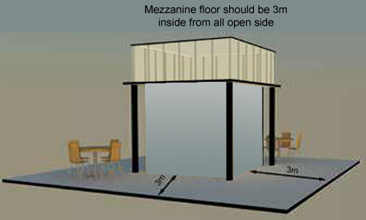

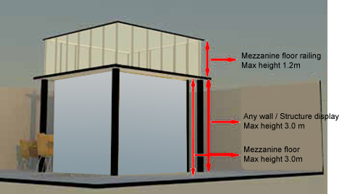

Railings

- Safety railings must be at least 1.2m high and consist of a top, middle and bottom rail.
- A strip of at least 0.10m must be mounted along the edge of the mezzanine floor beneath the railing to prevent falling objects.
- Walls adjoining neighbouring stands on the mezzanine floor must be sufficiently stable so as to prevent accidental falling of persons or objects.

Fire preventation

- Any load bearing elements of the mezzanine floor must be flame retardant.
- The mezzanine floor should be equipped with at least one fire extinguisher.

  - Seller Nominated Booth Contractor

As Organizer / Show Manager, we recognize that each Seller selects the booth contractor that they believe will best serve their needs before, during and after the Exhibition.

If a Seller chooses to engage such a booth contractor other than the Official Contractor, we are happy to have them on the Exhibition Floor.

However along with the growing number of these booth contractors on the Exhibition Floor have come numerous added expenses - related costs resulting from an increase in liability claims, Hall damage, excess cleaning charges, and extra administrative costs for badging, contractor, insurance tracking, security etc.

Rather than passing on these added costs to all Sellers, including those who do not use such contractors, we have implemented a formal approval, fee and performance bond system.

(a) Sellers (or their nominated booth contractors) are required to submit for approval, stand layout plans, elevation and artist’s impressions, in duplicate to the Official Contractor “Incredible Design” office by Saturday, 8 August 2015, together with their nominated contractor’s details (company name, address and contact person’s name) using Form 9A or Form 9B. This is to prevent costly alterations being required on-site, Hall Owner and / or Organizer / Show Manager. All drawings must have clear dimensions and scale drawings should not be smaller than 1:200. Faxed copies are acceptable, but original drawings must be submitted for final approval. Late submission may mean that approval may not be granted in time for construction to commence on site. And although such an approval may have been given already, the Organizer / Show Manager Reserves the right to request the Seller concerned to modify certain portions of their booth to meet Hall or government or the Exhibition’s prevailing conditions and circumstances. And please note that the design must include booth number.

- Before the nominated booth contractor is permitted to start work in hall, either he or his employing Seller / group is required to pay a non-refundable administrative / management fee and refundable performance bond to INCREDIBLE DESIGN, please refer Form 9B and sign an undertaking to guarantee conduct and behaviour, proper schedule of works, and observance of the Exhibition and Hall regulations. The Organizer / Show Manager reserves the right to increase this maximum limit on any Seller and their contractor who had previously performed or behaved unsatisfactorily, without having to assign any reason.

Only when the performance bond and administrative / management fee are received and the Undertaking signed, will the contractor be allowed to bring stores into the Hall and commence work.

All Performance bond and administrative / management fee monies must be lodged in T/T or cashier’s orders. Please note that any bank charges, levies or exchange rate differences will be deducted accordingly from the performance bond money. No banker’s guarantees (BG), credit card payments, or other forms than those stated are acceptable for this purpose. Contractors will also have to bear any charges levied by the Hall Owner for damages caused to their property and / or flooring.

Contractors, especially foreign-based ones must engage a local sub-contractor for the installation and dismantling works. They should make prior arrangements with the Official Cleaning Contractor for the cleaning and disposal of waste materials daily during the Build-up and Breakdown periods. The standard working areas used and occupied by the contractors should be kept tidy at all times.

Provided that the booth is completed by 2100 hrs. on Tuesday, 8 September 2015, unused materials and debris disposed of and discarded, and no damage is caused or any claim made during the build-up, breakdown and Exhibition days, the Performance Bond will be returned to the contractor in full, within 30 days of the completion of the Exhibition.

Five (5) Contractor Badges will be issued for every 9 sq. m. of construction, up to a maximum of thirty (30) badges per contractor.

Please note that a complete name list, with details of identification card / passport / work permit numbers must be provided.

A limited number of contractor badges for maintenance work or standby crew will be issued by the Organizer / Show Manager on a case-by-case basis, upon receipt of written application by the contractor concerned.

All foreign employees and staff must be in possession of valid work permits. We expect Government Officials to visit during build-up, to check on work permit. Please note that the issuance of Seller and Contractor Badges by the Organizer / Show Manager does not imply in anyway that permission is granted for any person to work onsite without the necessary permits.

