ELECTRICAL FACILITIES RENTAL


PATA Travel Mart 2015
6-8 September, Bangalore
DEADLINE: 4 August 2015

Return Form to:

Incredible Des!gn
B 143, First Floor,
Mayapuri Industrial Area,
Phase 1, New Delhi, 110064
Contact: +91(0)9810149570
Fax: +91-22-66459233
Attn: Mr. Sanjay Soni
Email: ptmindia2015@gmail.com

Furniture Orders
FORM
4

This form must be completed and returned by every exhibitor (if needed).

Company Name: _____ Country: __________________________________
Booth No.: ___ __ Contact Person: _________________________________ Email: ____________________________
Tel: _____________________________ Website: __________________________________ Date: ____ _____________

The Standard Shell Scheme Package stand includes:-
- One (1) Round Table I Four (4) Chairs I One (1) Wastepaper Basket

ORDER ONLY YOUR ADDITIONAL EQUIPMENT !

Code No. | Items | Description |  | Unit Price (INR) | QTY | Total Price (INR)
Code No. | Items | Color/Kind | Dimension in mm | Unit Price (INR) | QTY | Total Price (INR)
FURNITURE
C1 | Folding Chair | white & gray | 510 (L) X470 (W) X 720 (H) mm | 650
C2 | Office Chair | Black & blue | 500 (L) X 600 (W) X 800 (H) mm | 1100
C3 | Single Sofa | White & black | 600 (L)X 750 (W) X 600 (H) mm | 3000
C4 | Double Sofa | White & black | 1200 (L)X 750 (W) X 600 (H) mm | 6000
S1 | Stool Chair | chrome & white | 600 (W) X 1000 (H) mm | 1650
T1 | Table — Round | chrome & white | 800 (W) X 750 (H) mm | 1550
T2 | Table — Round glass | chrome & glass | 750 (W) X 750 (H) mm | 1700
T3 | Coffee Table | glass & white | 500 (L) X 600 (W) X 500 (H) mm | 1100
STORAGE & DISPLAY
D1 | Reception Desk | chrome & white | 1000 (L) X 500 (W) X 750 (H) mm | 1800
D2 | Reception Desk | chrome & white | 1000 (L) X 500 (W) X 1000 (H) mm | 2400
D3 | Low Glass Case | chrome & white +glass | 1000 (L) X 500 (W) X 1000 (H) mm | 3500
D4 | High Glass Case | chrome & white +glass | 500 (L) X 500 (W) X 2000 (H) mm | 4000
D5 | Shelf Rack | chrome & white | 1000 (L) X 500 (W) X 2000 (H) mm | 750
D6 | Lockable Cupboard | chrome & white | 1000 (L) X 500 (W) X 750 (H) mm | 2800
STRUCTURE ACCESSORIES
SA1 | Wall Panel | Chrome & white | 1000 (W) X 2500 (H) mm | 1400
SA2 | Door | White | 1000 (W) X 2100 (H) mm | 2600
SA3 | Fascia Board | White | 250 mm high | 750
L1 | Literature Holder – Zig Zag | Chrome & acrylic | 1500 (H) mm A4 | 1900
L2 | Literature Holder – Wall mount | Acrylic | 1300 (H) mm A4 | 650
CH1 | Coat hanger | Chrome | 1000 (L) mm | 950
ELECTRICAL ACCESSORIES
R1 | Refrigerator | White 165 ltr | 1370 (H) mm | 9000
 |  |  |  | Total cost (INR)
* Please indicate the locations of the above requirements on FORM 5 (Service location Plan) |  |  |  | Service Tax 14%
 |  |  |  | Grand Total
* Late Orders & Payment (received after the deadline, 4 August) may not be provided and
if available, will be subject to a 30% surcharge and 50% surcharge for onsite orders (received
after the deadline, 1 September). Priority will be given to advance orders
PLEASE NOTE:
- Services will not be provided until payment has been received. Payment should be in favour of: Incredible Design
For Transfers:
INR | EURO | USD
Account Name: INCREDIBLE DESIGN  Account No : 05512020000809  IFSC Code(For RTGS):HDFC0000551  MICR Code: 110240086  SWIFT CODE: HDFCINBB  HDFC Bank Ltd. Shop No.1,  Community Centre, Phase-I,  Mayapuri, New Delhi-110064 | Account Name: INCREDIBLE DESIGN  Account No : 05512440000030  IFSC Code(For RTGS):HDFC0000551  MICR Code: 110240086  SWIFT CODE: HDFCINBB  HDFC Bank Ltd. Shop No.1,  Community Centre, Phase-I,  Mayapuri, New Delhi-110064 | Account Name: INCREDIBLE DESIGN  Account No : 05512430000061  IFSC Code(For RTGS):HDFC0000551  MICR Code: 110240086  SWIFT CODE: HDFCINBB  HDFC Bank Ltd. Shop No.1,  Community Centre, Phase-I,  Mayapuri, New Delhi-110064

Please email or fax to us a copy of your payment slip for confirmation.
- If payment is drawn in a foreign currency, please include the bank commission and please also note if the final amount received is less than the invoiced amount due to exchange rate variance, you will be responsible for reimbursing the relevant beneficiary.
- Late Orders & Payment (received after the deadline, 4 August) may not be provided and if available, will be subject to a 30% surcharge and 50% surcharge for onsite orders (received after the deadline, 1 September). Priority will be given to advance orders.
- 30 % cancellation fees will be imposed for cancellation of confirmed orders. Orders cancelled in set-up days and show days, the exhibitor will be liable for full cost of rental, and there will be no refunds.
- Exhibitor must indicate the furniture point on Form 5 (Service Location Plan). Otherwise, the furniture will be place the supply point on contractor’s discretion. Incredible Des!gn will not be responsible for any relocation. All relocation cost will be at exhibitor’s expense.
- All Prices are in INR.
- All materials to be available subject to availability and first come first served basis.
- Incredible design is entitled to add, alter, or amend these terms and conditions at its sole and absolute discretion without prior notice.

FURNITURE
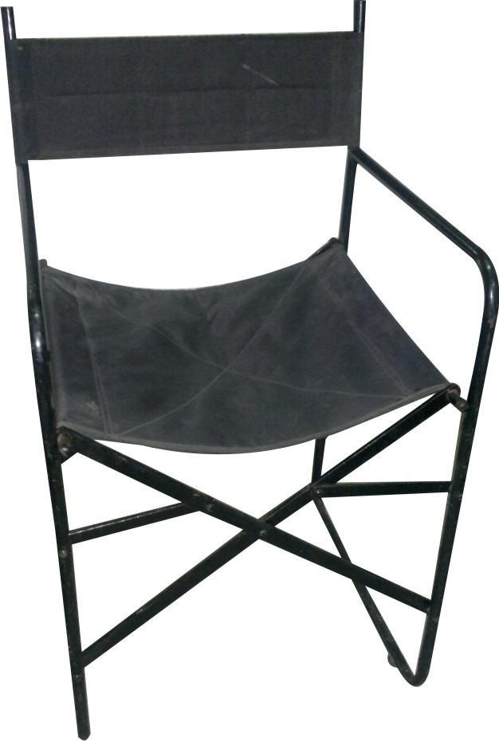 | 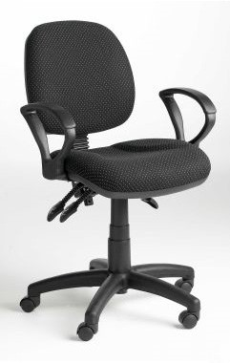 | 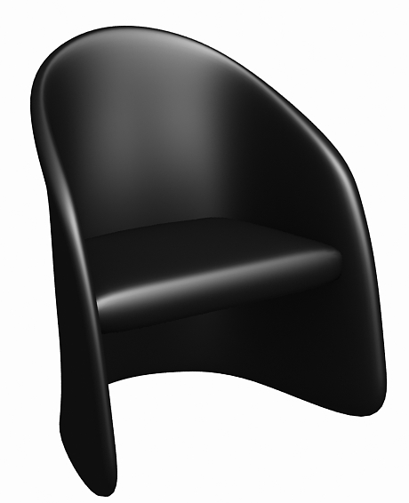 | 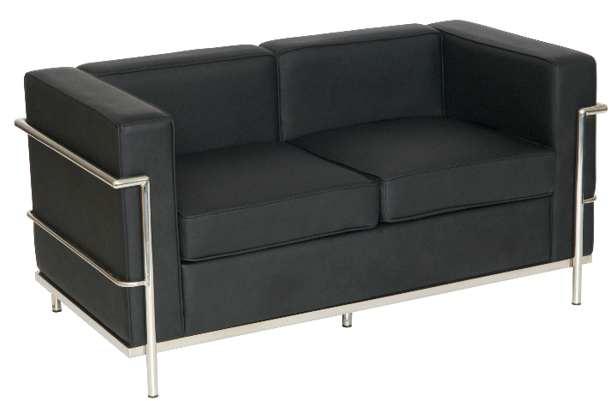
C1:  Folding Chair | C2:  Office chair | C3:  Single seater sofa | C4:  Double seater sofa
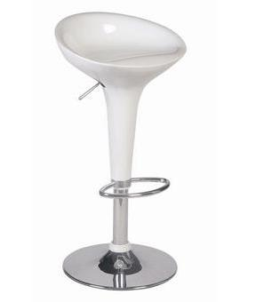 | 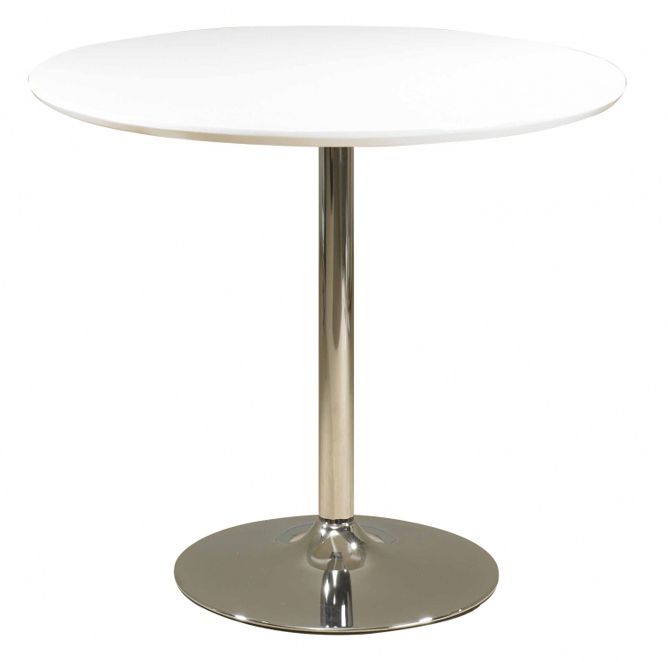 | 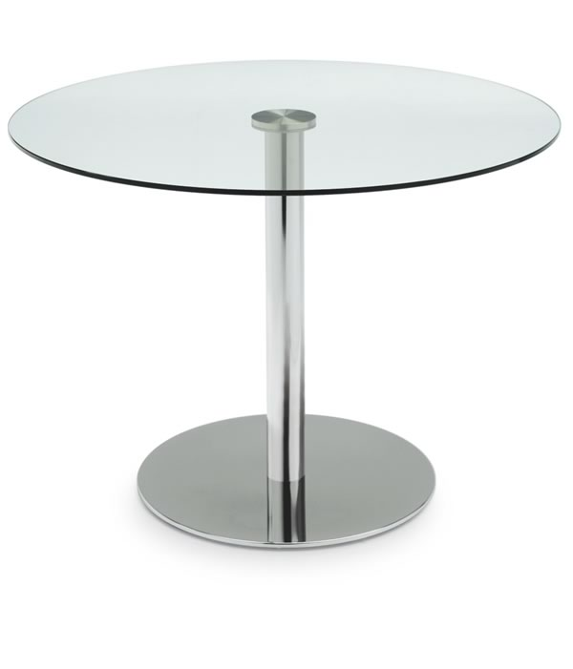
S1:  Stool Chair | T1:  Table - Round | T2:  Table – round glass | T3:  Coffee table
STORAGE & DISPLAY
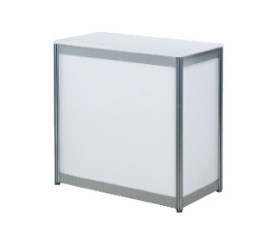 |  | 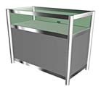 | 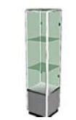
D1:  Reception Desk | D2:  Reception Desk | D3:  Low glass case | D4:  High glass case
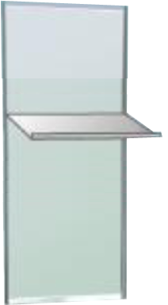 | 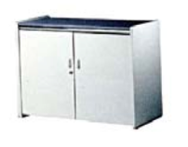
D5:  Shelf rack | D6:  Lockable cupboard

STRUCTURE ACCESSORIES
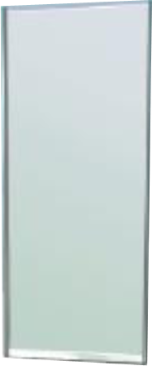 | 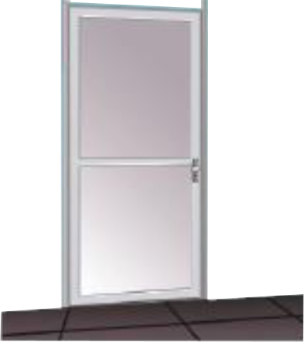 | 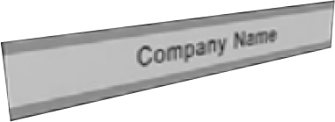 | 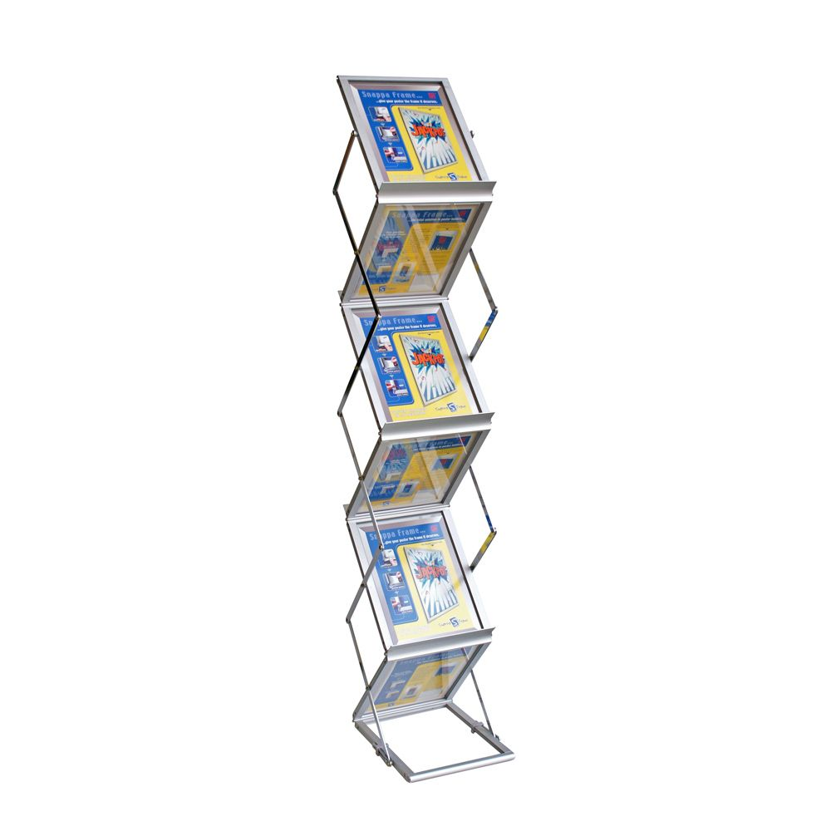
SA1:  Wall panel | SA2:  Door | SA3:  Fascia Board | L1:  Literature Holder – Zig Zag
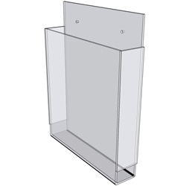 | 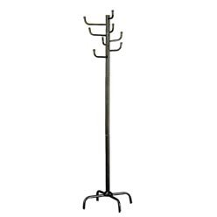
L2:  Literature Holder – Wall mount | CH1:  Coat Hanger
ELECTRICAL ACCESSORIES
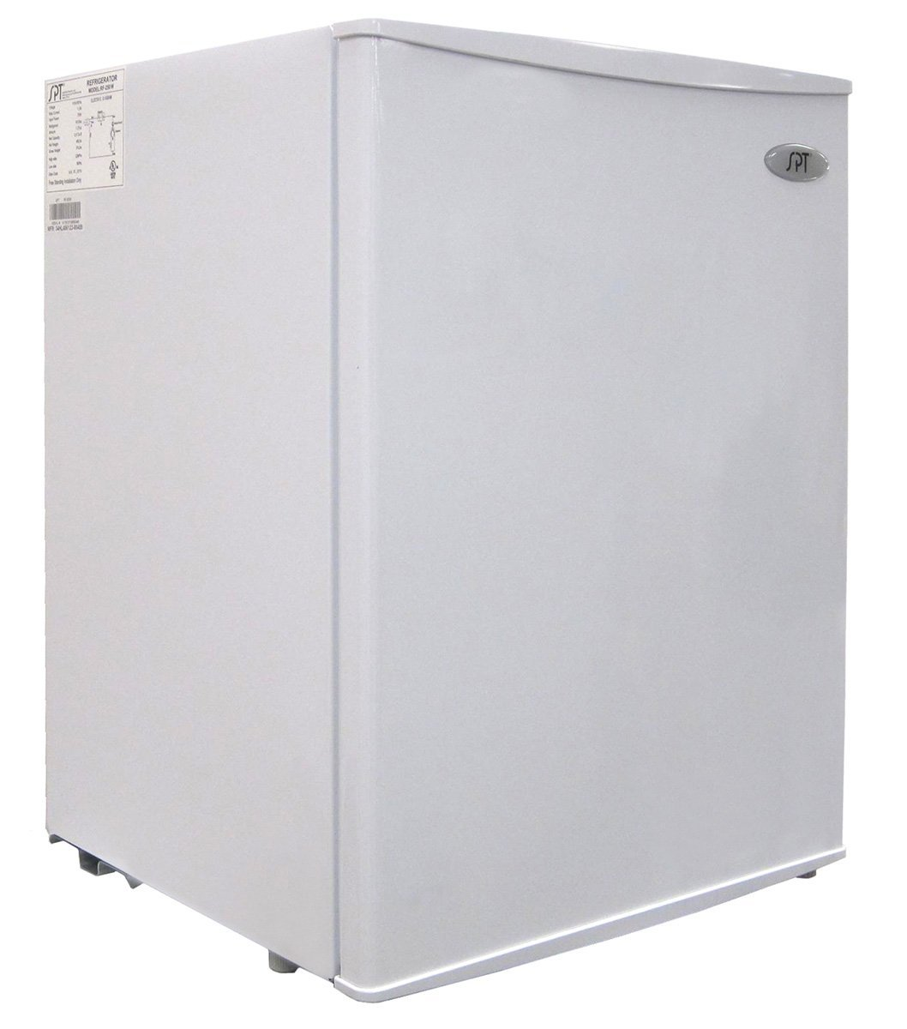
R1:
Refrigerator

