ELECTRICAL FACILITIES RENTAL


PATA Travel Mart 2015
6-8 September, Bangalore
DEADLINE: 4 August 2015

Return Form to:

Incredible Des!gn
B 143, First Floor,
Mayapuri Industrial Area,
Phase 1, New Delhi, 110064
Contact: +91(0)9810149570
Fax: +91-22-66459233
Attn: Ar. Sanjay Soni
Email: ptmindia2015@gmail.com

Electrical Services
FORM3

This form must be completed and returned by every exhibitor (if needed).

Company Name: _____ Country: __________________________________
Booth No.: ___ __ Contact Person: _________________________________ Email: ____________________________
Tel: __________________________ Website: __________________________________ Date: ____ ____________________

 | - The Shell Scheme Package includes two (2) 40W Fluorescent lights /one plug socket of 5/15Amp for every 9 square meters stand.
 | Order only your additional requirements
- For services not stated below, please contact the Official Contractor for a quotation.
- The supply available is 220V Single Phase50HzAC (1-5KW only) and 400V Three Phase 50HzAC.
DESCRIPTION OF SERVICES / ITEMS |  | Unit Cost (INR) within  4 Aug | Quantity | Cost  (INR)
EA1 | Fluoroscent light 1.2 meters, 40W | 850
EA2 | Spotlight 100W long arm | 850
EA3 | Halogen Spot 50W | 1300
EA4 | Arm Flood light 150W | 1500
EA5 | Plug socket, Standard 220 V, 5/15 amp | 850
SECTION B (For Raw Space) - BREAKER FOR LIGHTING (Supply of cable terminating in a fuse switch or connector, Wiring and maintenance are the responsibility of the contractor appointed by the Exhibitor)
EB1 | 15 Amp Single Phase | 3000
EB2 | 30 Amp Single Phase | 3000
EB3 | 15 Amp Three Phase | 3500
EB4 | 30 Amp Three Phase | 3500
EB5 | 60 Amp Three Phase | 3500
 |  | Total Cost (INR)
 |  | Service Tax 14%
 |  | Grand Total
- Please indicate the locations of the above requirements on FORM 5 (Service Location Plan).

- Please order separately in case you need electrical load during construction also.

- Late Orders & Payment (received after the deadline, 4 August) may not be provided and if available, will be subject to a 30% surcharge and 50% surcharge for onsite orders (received after the deadline, 1 September). Priority will be given to advance orders.

PLEASE NOTE:

- Services will not be provided until payment has been received. Payment should be in favour of: Incredible Design
For Transfers:
INR | EURO | USD
Account Name: INCREDIBLE DESIGN  Account No : 05512020000809  IFSC Code(For RTGS):HDFC0000551  MICR Code: 110240086  SWIFT CODE: HDFCINBB  HDFC Bank Ltd. Shop No.1,  Community Centre, Phase-I,  Mayapuri, New Delhi-110064 | Account Name: INCREDIBLE DESIGN  Account No : 05512440000030  IFSC Code(For RTGS):HDFC0000551  MICR Code: 110240086  SWIFT CODE: HDFCINBB  HDFC Bank Ltd. Shop No.1,  Community Centre, Phase-I,  Mayapuri, New Delhi-110064 | Account Name: INCREDIBLE DESIGN  Account No : 05512430000061  IFSC Code(For RTGS):HDFC0000551  MICR Code: 110240086  SWIFT CODE: HDFCINBB  HDFC Bank Ltd. Shop No.1,  Community Centre, Phase-I,  Mayapuri, New Delhi-110064

Please email or fax to us a copy of your payment slip for confirmation.
- If payment is drawn in a foreign currency, please include the bank commission and please also note if the final amount received is less than the invoiced amount due to exchange rate variance, you will be responsible for reimbursing the relevant beneficiary.
- 30 % cancellation fees will be imposed for cancellation of confirmed orders. Orders cancelled in set-up days and show days, the exhibitor will be liable for full cost of rental, and there will be no refunds.
- Exhibitor must indicate the installation point on Form 5 (Service Location Plan). Otherwise, the installation will be place the supply point on contractor’s discretion. Incredible Design will not be responsible for any relocation. All relocation cost will be at exhibitor’s expense.
- All Prices are in INR.
- All materials to be available subject to availability and first come first served basis.
- A socket must be used for one exhibit at one time. Multi-point connection is not allowed to prevent the risk of power overload.
- The standard supply is 220V with approximately 10% fluctuation. For the safety of your equipment, please use a stabilizer.
- 24hrs power supply has additional 50% charge of standard price. （limited to use small electrical equipment like refrigerator, charger, oxygenators）
- Incredible design is entitled to add, alter, or amend these terms and conditions at its sole and absolute discretion without prior notice.

ELECTRICAL EQUIPMENT (RENTAL)
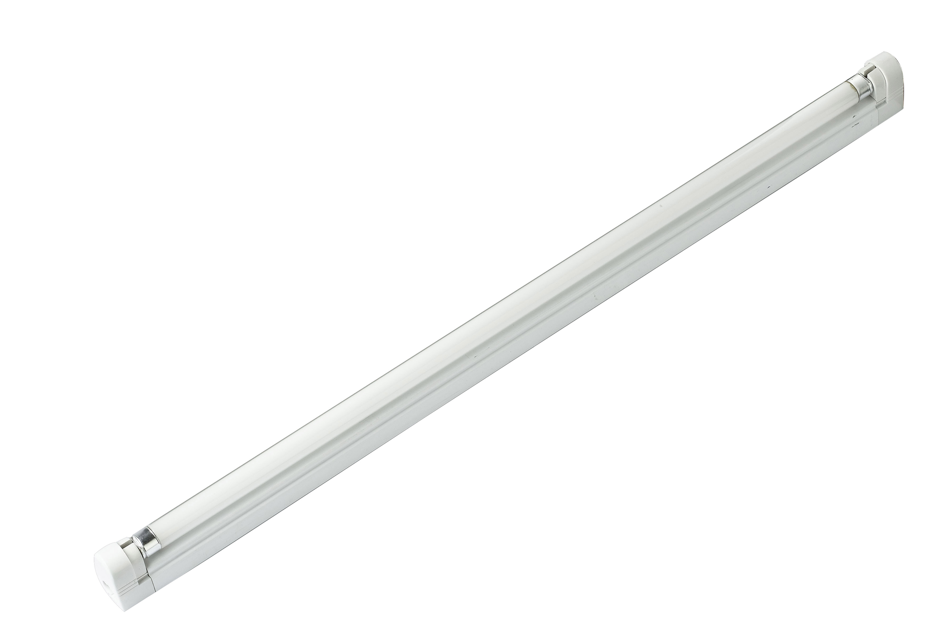 | 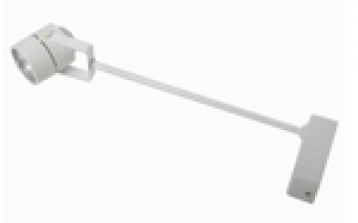 | 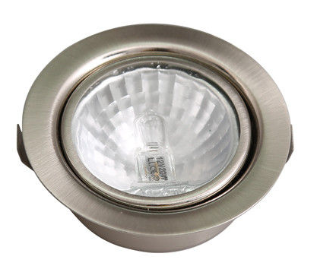 | 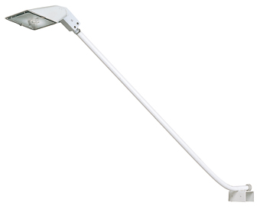 | 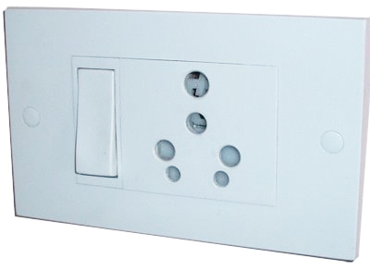
EA1:  Fluorescent light | EA2:  Spotlight | EA3:  Halogen spot | EA4:  Arm flood light | EA5:  Plug socket

