ELECTRICAL FACILITIES RENTAL


PATA Travel Mart 2015
6-8 September, Bangalore
DEADLINE: 4 August 2015
Return Form to:
FORM
10

Incredible Des!gn
B 143, First Floor, Mayapuri Industrial Area, Phase 1, New Delhi, 110064
Fax: +91-22-66459233
Mobile: +91(0)9810149570
Attn: Mr. Sanjay Soni
Email: ptmindia2015@gmail.com

Plant & Floral Rental Service

This form must be completed and returned by every exhibitor (if needed).

Company Name: _____ Country: __________________________________
Booth No.: ___ __ Contact Person: _________________________________ Email: ____________________________
Tel: _____________________________ Website: __________________________________ Date: ____ ____________

Items |  |  |  | Unit price per Event  (INR) | QTY | Amount (INR)
PF001 | Areca Lutescens (120cm) |  |  | 1400
PF002 | Kentia Palm (120cm) |  |  | 1600
PF003 | Ficus plant (100cm) |  |  | 1200
PF004 | Fern |  |  | 1200
PF005 | Table Bouquet (Ø 30cm) |  |  | 900
PF006 | Planter Box – Timber construction (30(w)x100(l)x30(H)) |  |  | 1100
PF007 | Planter Box – Moulded plastic (30(l)x30(w)x30(h)) |  |  | 900
 |  | (Black / White) | (Round / Square)
 |  |  |  | Total Cost (INR)
 |  |  |  | Service Tax 14%
 |  |  |  | Grand Total
PLEASE NOTE:
- Delivery of plant on last day of build-up.
- Late Orders & Payment (received after the deadline, 4 August) may not be provided and if available, will be subject to a 30% surcharge and 50% surcharge for onsite orders (received after the deadline, 1 September). Priority will be given to advance orders.
- Services will not be provided until payment has been received. Payment should be in favour of: Incredible Design
For Transfers:
INR | EURO | USD
Account Name: INCREDIBLE DESIGN  Account No : 05512020000809  IFSC Code(For RTGS):HDFC0000551  MICR Code: 110240086  SWIFT CODE: HDFCINBB  HDFC Bank Ltd. Shop No.1,  Community Centre, Phase-I,  Mayapuri, New Delhi-110064 | Account Name: INCREDIBLE DESIGN  Account No : 05512440000030  IFSC Code(For RTGS):HDFC0000551  MICR Code: 110240086  SWIFT CODE: HDFCINBB  HDFC Bank Ltd. Shop No.1,  Community Centre, Phase-I,  Mayapuri, New Delhi-110064 | Account Name: INCREDIBLE DESIGN  Account No : 05512430000061  IFSC Code(For RTGS):HDFC0000551  MICR Code: 110240086  SWIFT CODE: HDFCINBB  HDFC Bank Ltd. Shop No.1,  Community Centre, Phase-I,  Mayapuri, New Delhi-110064
Please email or fax to us a copy of your payment slip for confirmation.

- If payment is drawn in a foreign currency, please include the bank commission and please also note if the final amount received is less than the invoiced amount due to exchange rate variance, you will be responsible for reimbursing the relevant beneficiary.
- 30 % cancellation fees will be imposed for cancellation of confirmed orders. Orders cancelled in set-up days and show days, the exhibitor will be liable for full cost of rental, there will be no refunds.
- Exhibitor must indicate the service point on Form 5 (Service Location Plan). Otherwise, the plants will be place the supply point on contractor’s discretion. Incredible Des!gn will not be responsible for any relocation. All relocation cost will be at exhibitor’s expense.
- All Prices are in INR.
- All materials to be available subject to availability and first come first served basis.
- Incredible design is entitled to add, alter, or amend these terms and conditions at its sole and absolute discretion without prior notice.

Plant & Floral (Rental)
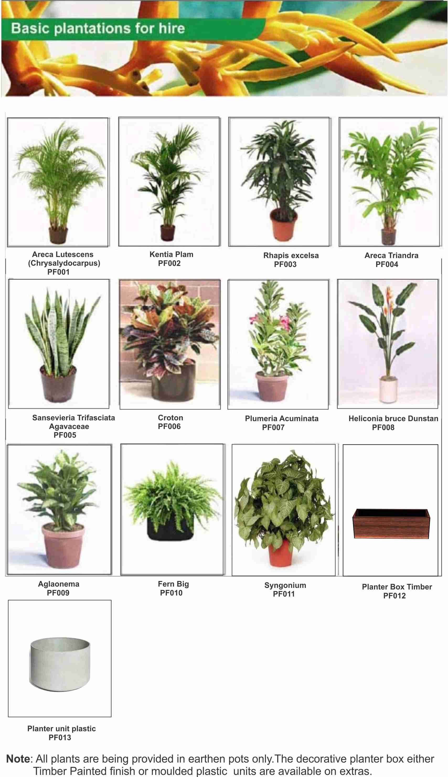 |  | 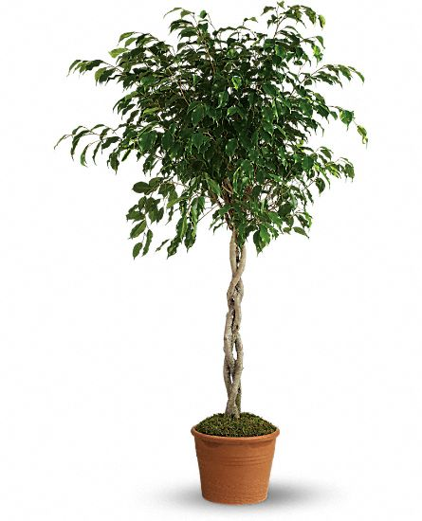
PF001:  Areca Lutescens | PF002:  Kentia Palm | PF003:  Ficus Plant | PF004:  Fern
AS PER AVAILABILITY
PF005:  Table Bouquet | PF006:  Planter Box – Timber | PF007:  Planter Box – Plastic

